

AdditiveManufacturing33(2020)101137
Contents lists available at ScienceDirect

Additive Manufacturing
journal homepage: www.elsevier.com/locate/addma

Full Length Article

Additive manufacturing of fracture fixation implants: Design, material characterization, biomechanical modeling and experimentation
Maryam Tiltona, Gregory S. Lewisb, Hwa Bok Weeb, April Armstrongb, Michael W. Hastc,
Guha Manogharana,*
a Department of Mechanical Engineering, Pennsylvania State University, University Park, PA, United States
b Department of Orthopaedics and Rehabilitation, Pennsylvania State University College of Medicine, Hershey, PA, United States
c Biedermann Lab for Orthopaedic Research, Department of Orthopaedic Surgery, University of Pennsylvania, Philadelphia, PA, United States

A R T I C L E I N F O

Keywords:
Metal AM Biomedical implants Fracture fixation AM design
FEA
Biomechanical testing L-PBF
Orthopaedic implants 316L
Sawbones Surgical fixtures CT
Material characterization of AM AM jigs and fixtures
Reverse engineering Synthetic bones
A B S T R A C T

Recent advancements in additive manufacturing (AM) have motivated researchers to consider this fabrication technique as a solution for challenges in patient-specific orthopaedic needs. Although there is an increasing trend in the applications of AM in medical fields, there is a critical need to understand the biomechanical performance of AM implants. In particular, design opportunities, anisotropic material properties and resulting stability of AM implant constructs for large bone defects such as osteosarcoma, comminuted fractures and infections are un- explored. This study aims to evaluate metal AM for complex fracture fixation using both computational and experimental methods. In addition, this research highlights the role of AM in the entire workflow to fabricate metal AM fixation plates for treatment of comminuted proximal humerus fractures. A new AM-centric patient- specific implant design for reducing common postoperative complications such as varus collapse and screw
cutout is investigated. Biocompatible 316L stainless steel specimens processed in laser-powder bed fusion (L- PBF) is subjected to tensile testing and post-hoc microhardness to obtain orthotropic material properties of the AM implants. Subsequently, risk of screw cut-out is evaluated using finite element modelling (FEM) of AM implant-bone constructs. Parallel experiments included synthetic bones that are evaluated using a 3D motion capture system. The biomechanical tests are analyzed to quantify the medial fracture gap displacement among study groups subject to different loading conditions. The outcomes of this study suggest that the proposed AM- centric fixation plate design reduces average varus collapse (i.e. medial fracture gap displacement) by 47.2 % and risk of screw cut-out by 14.6 % when compared to the conventional plate design. Findings from this study can be extended to other patient anatomy, loading conditions, and AM processes.

Introduction
The inherent layer-by-layer process characteristics of additive manufacturing (AM) enables selective joining of materials to fabricate complex geometries with high degree of customization directly from computer aided design (CAD) models. This has made AM fabrication technique into an attractive alternative to subtractive manufacturing (SM). In recent years, AM technologies have garnered significant in- terest from the orthopaedic industry as a potential means to fabricate patient-specific orthodontics and implants. In particular, powder bed fusion (PBF) techniques that include laser-powder bed fusion (L-PBF)
and electron beam melting (EBM) have been of focus for both industries and researchers. Furthermore, AM technology has facilitated evaluation and progression of the topology optimization field. In recent efforts, researchers have employed topology optimization methods along with AM to reduce the weight and materials usage of the orthopaedic im- plants while improving the bio-mechanical performance [1–3]. The majority of reported studies on AM orthopaedic implants has primarily focused on hip [2,4,5], knee [6], clavicle [7] and cranial [8] re- constructions. A thorough literature review (Table 1) of current reports on application of AM shows an underexplored surgical need that could be addressed by the unique capabilities of AM: namely, implants for

Abbreviations: AM, additive manufacturing; CAD, Computer aided design; CMM, Coordinate Measuring Machine; EBM, Electron beam melting; EDM, Electron discharge machining; FEA, Finite element analysis; L-PBF, Laser powder bed fusion; MS, Medial strut; PLA, Polylactic Acid; RE, Reverse engineered; ROI, Region of interest; STL, Stereolithography; SM, Subtractive manufacturing
⁎ Corresponding author.
E-mail address: gum53@psu.edu (G. Manogharan).
https://doi.org/10.1016/j.addma.2020.101137
Availableonline13March2020
Received 26 August 2019; Received in revised form 15 January 2020; Accepted 16 February 2020
2(h2t1tp4:-/8/6c0r4ea/t©ive2c0o2m0mTohnes.Aourgth/olircse.nPsuesb/liBsYh-eNdCb-yNDEl/s4e.v0i/e)r.B.V.ThisisanopenaccessarticleundertheCCBY-NC-NDlicense

Table 1
Brief review of published scientific literature on two major applications of AM in orthopaedics - fabrication of implants (blue) and surgical guides (green) [2,4,6,7,13–15,26–40]. (For interpretation of the references to colour in this figure legend, the reader is referred to the web version of this article.)
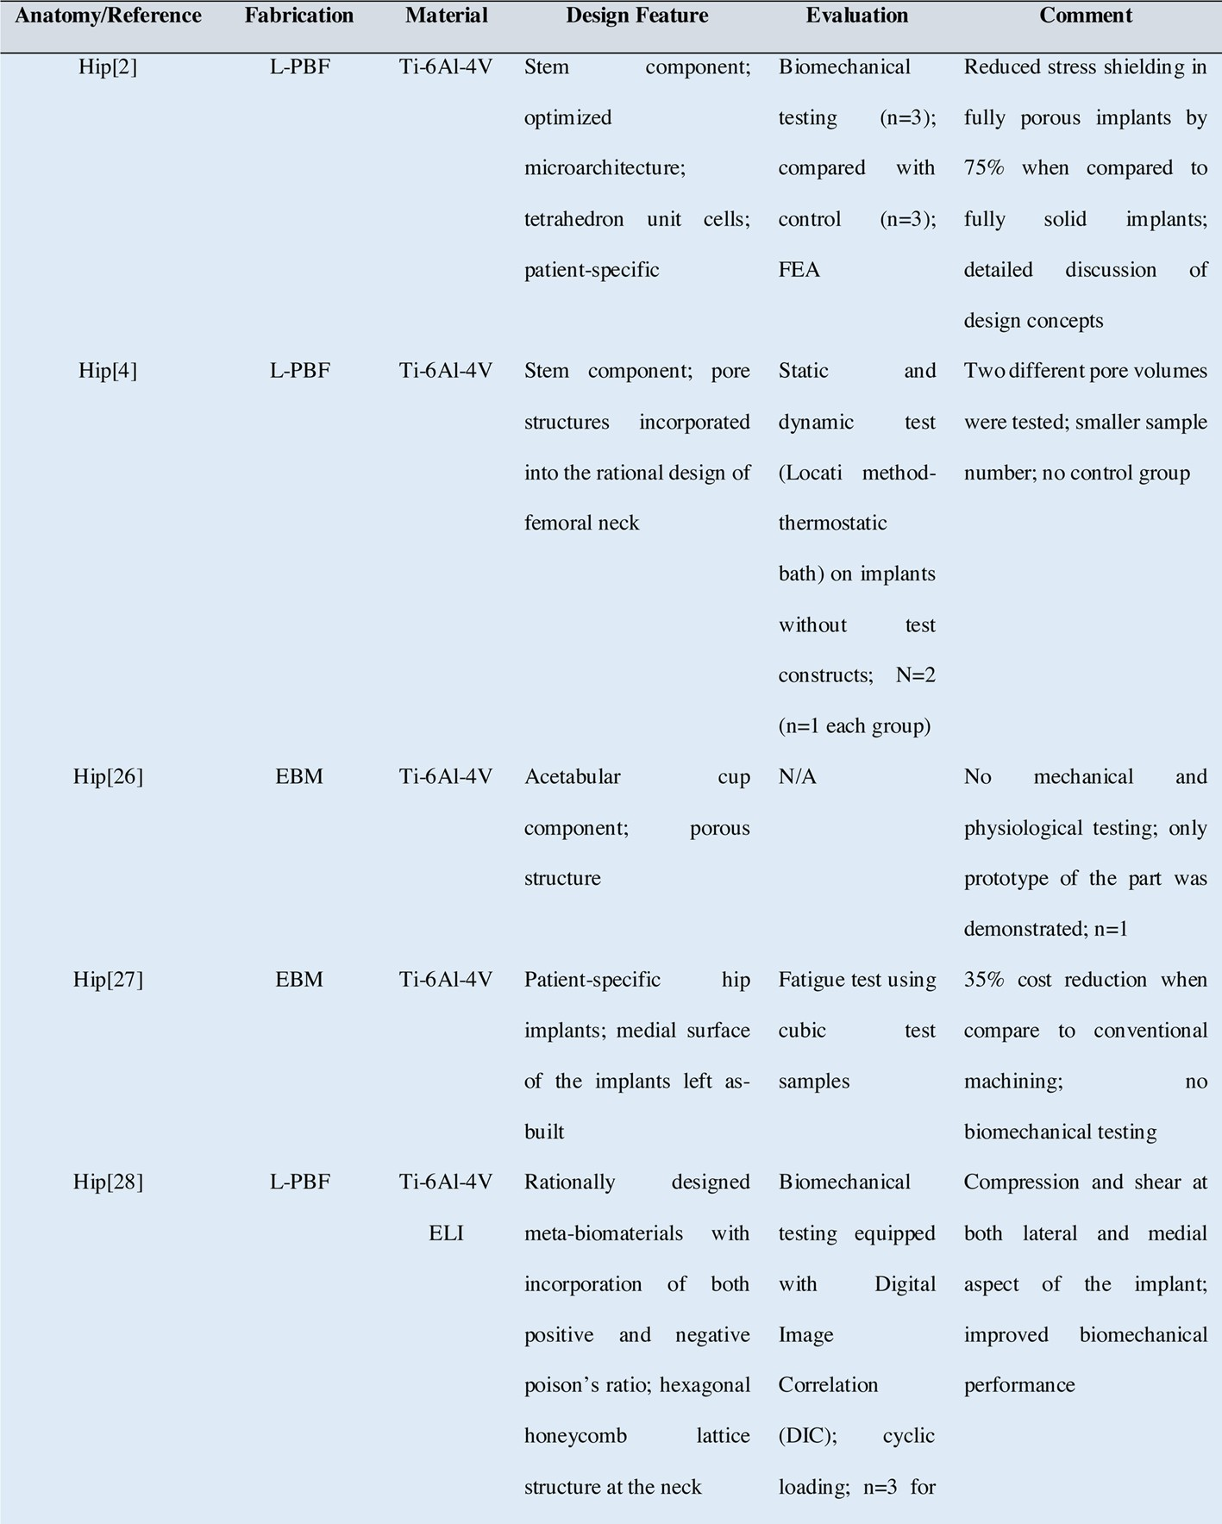
(continued on next page)

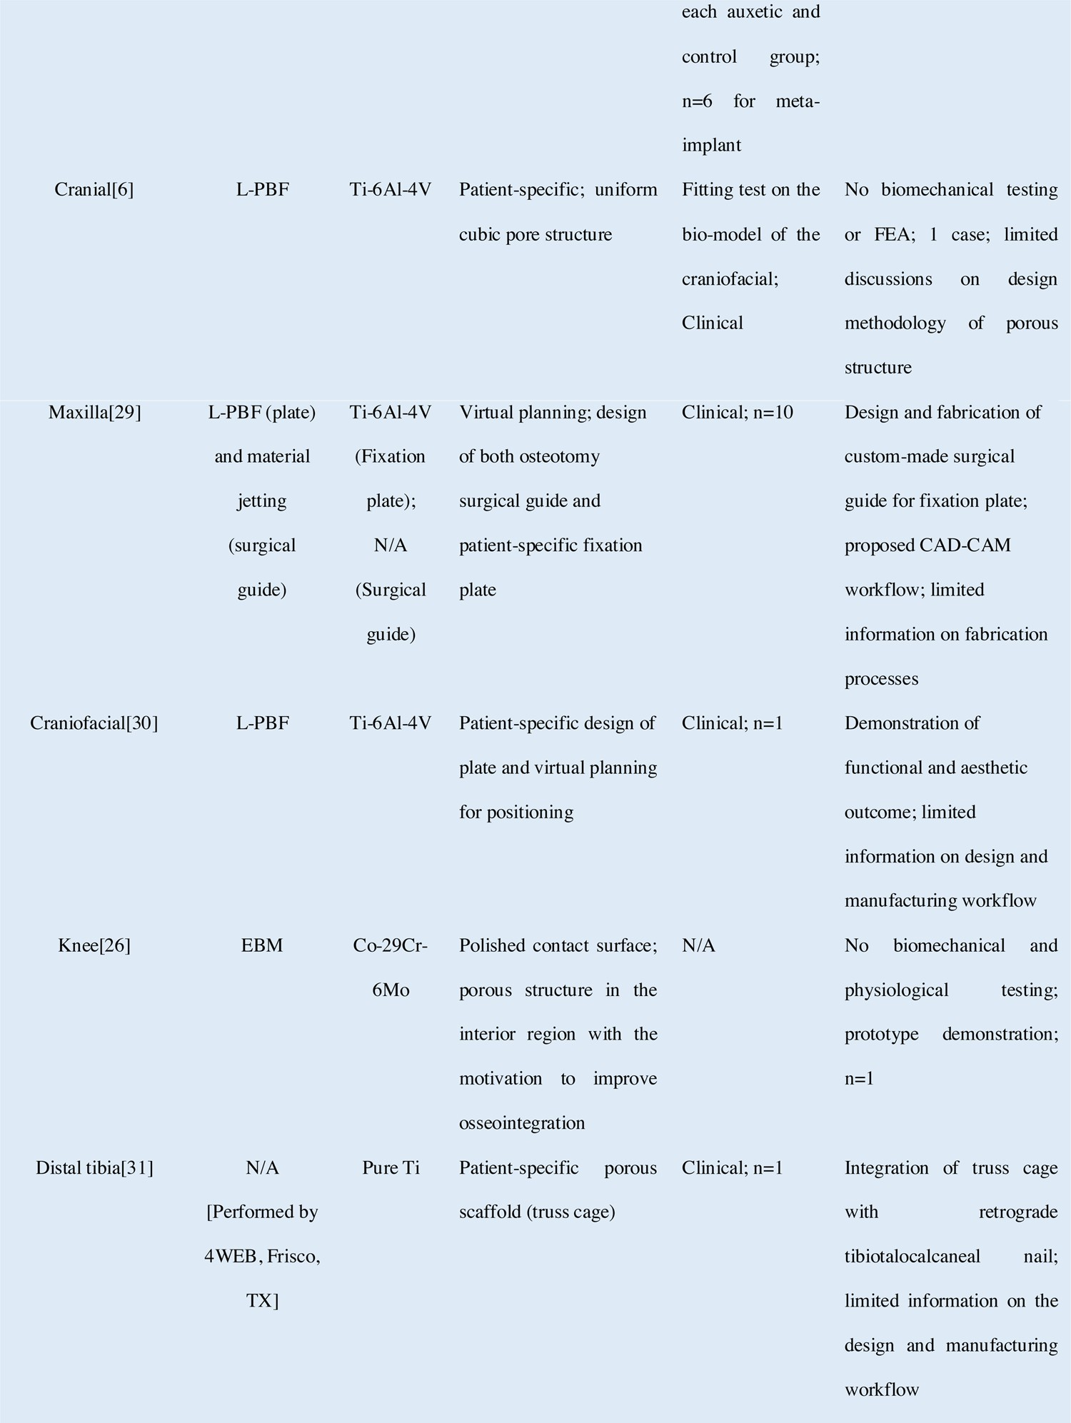
(continued on next page)

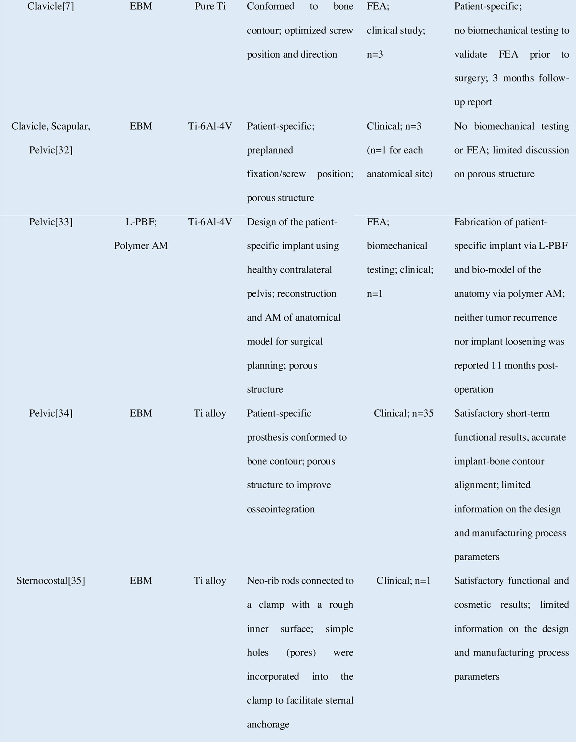

(continued on next page)

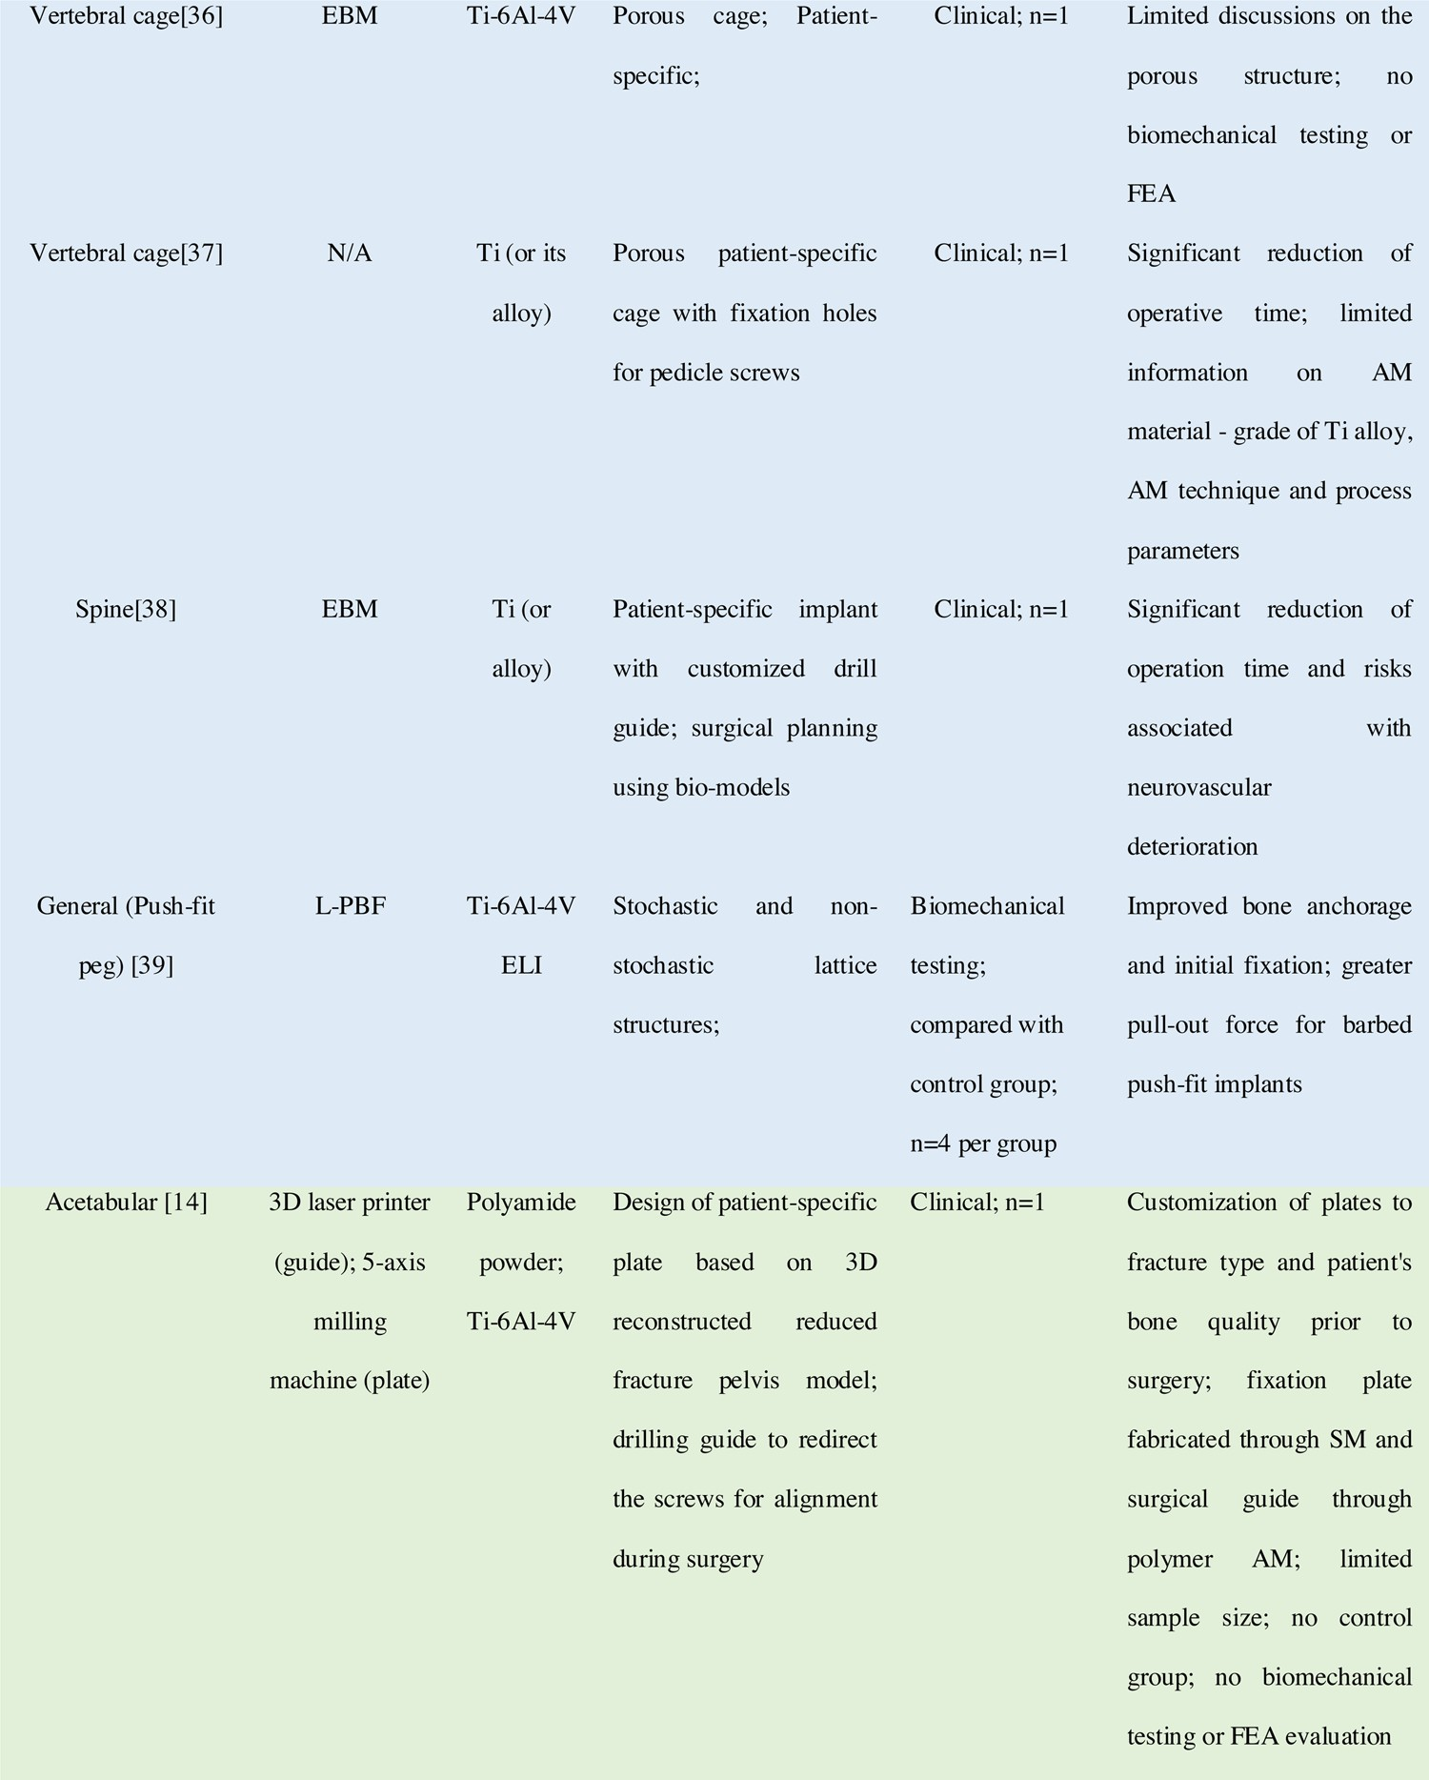
(continued on next page)

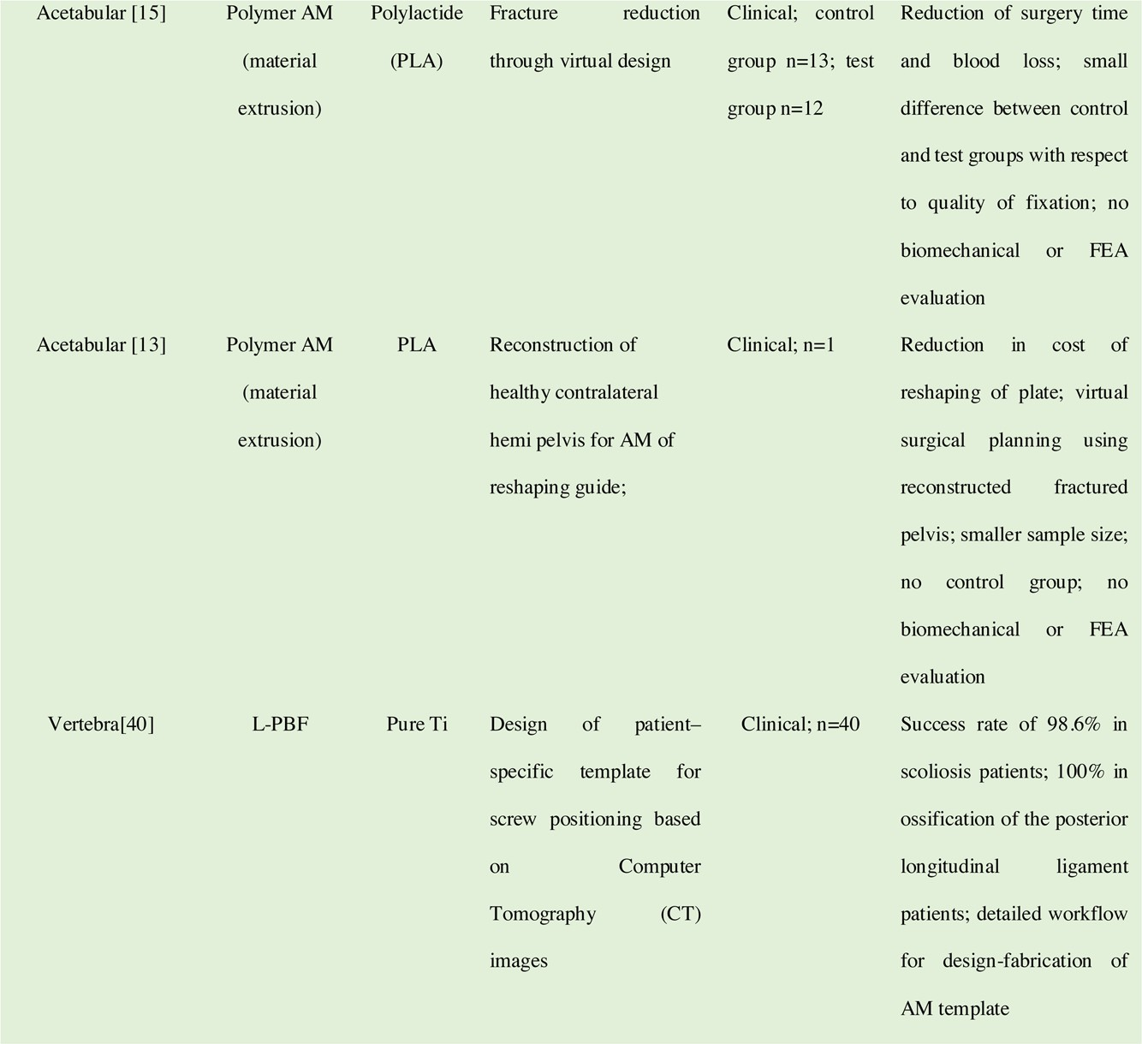

complex fracture fixation [9–11]. For instance, several studies on acetabular fracture fixation harnessed the potential of AM only to create surgical guides for preoperative planning or reshaping the fixa- tion plate [5,12–15]. Clinical studies showed that pre-contouring the plate could enhance the efficacy of fixation by reducing the implanta- tion time and blood loss [13,15]. However, pre-contouring the fixation plate using a reshaping-template could be both an inefficient and in- accurate method at acute angles. Such issues could be eliminated through patient-specific AM fracture fixation plates that have been conformed to the bone and defect contour prior to fabrication. How- ever, there is a critical lack of understanding about the biomechanical behavior of the AM-made fixation plates that needs to be addressed prior to clinical evaluation. This challenge is further amplified by the variation due to build-orientation on material structure and resulting mechanical properties, i.e. anisotropy in metal AM. The current state of
the PBF metallic AM implants has been summarized in recent published
reports [16,17]. Burton et al. [18] reported a detail literature review on design decisions, process selection, economic impact, and fabrication work flow of the published reports on AM implants. It was highlighted that the lack of information on the design and manufacturing processes provided by many of these reports restricts the reproducibility, bio- mechanical and clinical evaluation of the presented implant design concepts.
The aim of this study was to establish a systematic framework for the design and AM manufacturing workflow of proximal humerus fracture fixation locking plates through computational and experi- mental validation methods. Locking fixation plates exhibit fixed-angle screw projections in which screw heads are locked in the threaded chambers on the plate. Although, locking plates offer better mechanical stability compared to non-locking mechanisms, and are the current treatment systems for reconstruction of proximal humerus fractures [11,19,20], there is still a high rate of postoperative complications such
as varus collapse and screw cutout through the humeral head associated with these implants [21–25]. Specifically, the role of AM through the process of reverse engineering of a conventional fracture fixation locking plate geometry, design and L-PBF fabrication of novel design concepts, design and fabrication of jigs and surgical guides, and com- putational analysis (Finite Element Analysis-FEA) are illustrated in this study. This study compares the biomechanical performance of locking plates fabricated via L-PBF process with conventional manufacturing, and it proposes novel designs that are made more feasible via AM. Mechanical stability is evaluated through a series of biomechanical testing and finite element analysis (FEA). In-vitro quasi-static bio- mechanical testing along with 3D motion capture was performed to evaluate the resistance of these varying implant constructs to medial fracture gap displacement (i.e. varus collapse). FE analysis was per- formed to estimate the risk of screw cut-out.
As shown in Fig. 1, novel workflow includes: (1) to the best of au-
thors’ knowledge, the first reported study on evaluation of metal AM (L- PBF) to fabricate proximal humerus fracture fixation plates, (2) in- tegration of AM process throughout the work-flow of design, AM pro- cessing, post-processing and preparation of test constructs, (3) design- fabrication-evaluation of novel medial strut design concepts in place of media-inferior screws, and (4) incorporation of orthotropic material properties rather than linear elastic isotropic properties into FE mod- eling.

Materials and methods
This section details the reverse-engineering, novel design concepts, AM processing methods, post-processing materials, test construct pre- paration through AM surgical guides, FEA and in-vitro biomechanical testing protocols employed in this study (Fig. 1). The design of ex- periments is developed to understand effects of AM fracture fixation

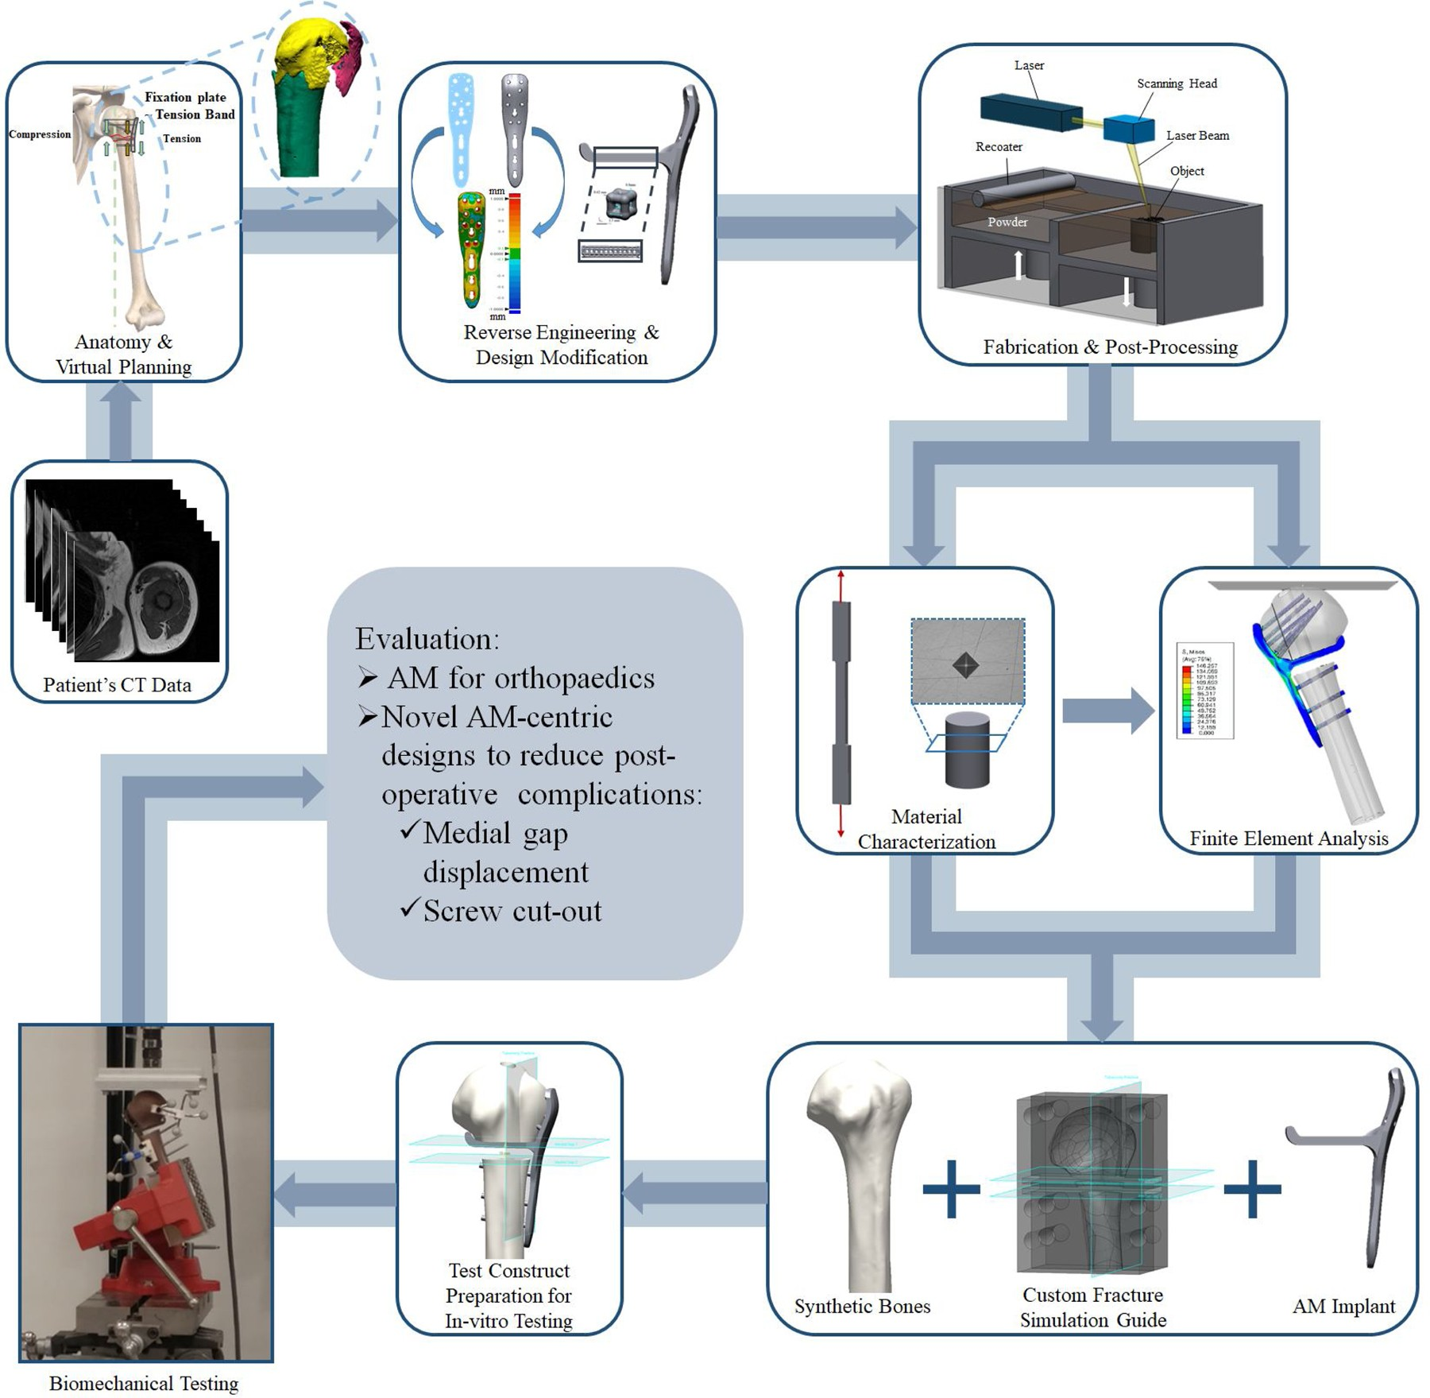
Fig. 1. Schematic diagram of the general workflow to evaluate AM for orthopaedic applications.

implants on the biomechanical behavior of fractured bone construct; specifically, mean compressive strains of the trabecular bone around the proximal screws and fracture gap displacement under physiologi- cally relevant loading conditions were investigated. The main hypoth- esis of this study was that replacing the calcar screws in the conven- tional implant design with an AM-customized medial support would reduce the proximal head displacement and risk of screw cut-out.
  - Design
Systematic reverse engineering techniques using a FARO Arm
deviation between the reconstructed parametric CAD model and point cloud scan data. Extracting an accurate CAD model of the conventional plate enables reliable comparison between forged (i.e. conventional) and AM locking plates by minimizing variabilities in feature geome- tries.
Optical measurements along with CMM were employed to obtain the screw hole centerline vector at each screw level for the conventional plate group. This information was used to accurately model the holes that lock with the screws in the parametric CAD model. Since creating threads using AM processes is still a challenge, holes with a diameter of
3 mm were incorporated into the CAD model. Threaded holes with a

Coordinate Measuring Machine (CMM) and blue-light 3D Laser Scanner
diameter of .5 mm were manually created through tapping with the aid

(FARO Technologies, Inc., Florida, USA) were employed to obtain a parametric CAD model of a conventional fracture fixation locking plate for proximal humerus fractures ( .5 mm LCP Proximal Humerus, DePuy Synthes). Scanning rate of 560,000 points per second resulted in a re- solution of 0.0254 mm to generate a highly accurate point cloud re- presentation of the implant. The point cloud data was processed in Geomagic Design X 16.11 (3D Systems, Inc., USA) to generate an STL model using automated triangulation algorithm. A parametric CAD model of the plate was obtained by extracting relevant geometrical features. Accuracy analysis was performed to evaluate the dimensional
of a polymer AM jig. Suture holes in the plates were ignored in this study since synthetic bones (Large Left 4th Gen Composite Humerus, 10# solid foam cancellous core, Sawbones, Vashone, WA) were used in the biomechanical testing. The rationale behind using synthetic bones included: (1) avoiding high variability inherent in cadaveric bone structures [41,42], (2) significantly higher costs of cadaver specimens that would have restricted the number of trials [41], and (3) ability to benchmark findings from this study against reported work using similar synthetic bones [42].
The parametric CAD model of the conventional locking plate was

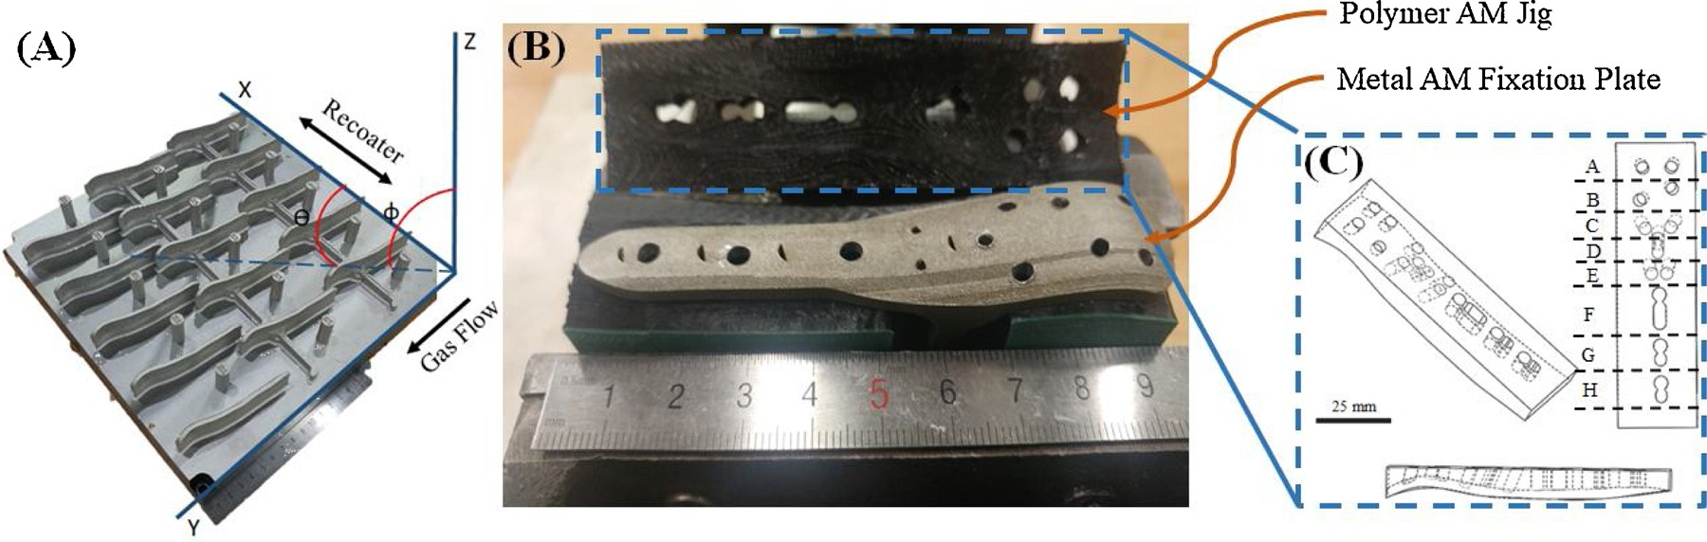
Fig. 2. (A) representative build of fracture fixation plates along with test coupons and (B) custom polymer AM jig for tapping and creating fixed-angle screw holes (C).

modified for patient-specific bone model and fracture type for three design concepts: (1) reversed-engineered (RE) plates to mimic con- ventional fixation plate’s geometry, fabricated at two orthogonal or- ientations (RE_{Y}, RE_{Z}), (2) plate with solid medial strut as an alternative medial support solution (MSS_{Y}), and (3) plate with porous medial strut (MSP_{Y}). The rationale behind the design of medial strut was to provide improved mechanical stability to the humeral head by supporting it with stronger medial cortex bone, as opposed to calcar screws that are fixed to weaker cancellous bone in current implants. Placing the locking calcar screws specifically through the medio-inferior region of the hu- merus head has been shown to be important for improved stability in comminuted cases [19,43]. However, current rates of complications [23–25] indicates that calcar screws have not been sufficient for pro- viding the required medial support in displaced fractures.
Anisotropic mechanical properties of L-PBF objects has been an area
of interest for researchers in recent years. Mechanical properties of the L-PBF parts can vary based on their orientation, azimuth and polar angle with respect to build plate as shown in Fig. 2A. In this study, the reversed-engineered (RE) group was fabricated in two different or- ientations, perpendicular to the build direction (RE_{Y}) and parallel to the build direction (RE_{Z}). Information regarding the build orientation of the
study groups is detailed in Table 2. Additionally, uniform cube edge lattice structures with unit cell size dimensions of 1.5 1.5 1.5 mm, strut diameter of 0.8 mm, and porosity of 61 % were employed in the proposed medial support design in order to evaluate potential differ-
ences in biomechanical behavior between solid and porous medial support. The rationale behind incorporation of this pore structure was to understand the change in biomechanical behavior of the solid medial strut vs. porous strut considering the latter concept allows for bone ingrowth into the pores [44–46].

  - Manufacturing
The build plan was prepared using 3DXpert (3D Systems, Inc., USA) software. The parts were offset at 3 mm from the build plate with solid support structure for wire-Electro Discharge Machining (EDM)
Table 2
Summary of the test groups and the AM implant orientation in the build en- vironment.
(Fig. 2A). Prepared build was manufactured on ProX DMP 320 machine (3D Systems, Inc., USA) with layer thickness of 60 µm using standard parameters listed in Table 3. Commercially available virgin SS316L spherical powders (Balance_Fe-17.0Cr-12.0Ni-2.5Mo-2.3Si-0.03C, FE- 101, Praxair, Indianapolis, IN, USA) with a size distribution of
40 63 µm were used as the feedstock material. Energy density was
calculated in accordance to Eqn. 1 [47,48].

Energy density [J /mm]
=

laser power (W )
× ×
layer thickness (mm) hatch distance (mm) scan speed (mm/s)
(1)
Post-AM build plates underwent thermal treatment in accordance with SAE AMS2759/11 standard [49] for residual stresses. It has been well established that high variation in thermal gradients during the L- PBF process may lead to formation of residual stresses, crack, and dis- tortion [50]. The predominant contributors to the buildup of residual stresses are high thermal gradient, volumetric changes during phase transformation, and variation in coefficient of thermal expansion be- tween the feedstock material and the substrate [50,51].
In order to minimize these challenges, stainless steel substrate was used to eliminate the buildup of residual stresses imposed by difference in coefficient of thermal expansion between the feedstock material and the substrate. Additionally, residual stress relief was performed in a vacuum furnace with maximum temperature of 450 for one hour. After heat treatment and wire-EDM of parts off the build plate, a custom-built aluminum jig was used to cut the support from the fixation plates using Wire-EDM in order to machine the plates to final geometry (i.e. conventional plate geometry).
In order to replicate the locking mechanism of conventional plates into the L-PBF fixation plates, matching fixed-angle threaded holes for ANSI 6-32 screws using custom Acrylonitrile Butadiene Styrene (ABS) tapping guides (Fig. 2B–C) were fabricated using material extrusion (Sell’s Mendel RepRap). Total time for fabrication and post-processing of the implants including custom jig was only 23 h.
Table 3
L-PBF process parameters.
Process Parameters Scan Laser Hatch Rotation Energy
mm

Group Sample # Manufacturing Method
Material Azimuth
angle ( )
Polar angle ( )
Speed (mm )
Power (W )
Distance ( )
Angle increment (deg )
Density ( J 3 )

Conventional 3 Forging SS316L – – RE_{Y} 3 L-PBF SS316L 90 0
RE_{Z} 3 L-PBF SS316L 90 90
MSS_{Y} 3 L-PBF SS316L 90 0
MSP_{Y} 3 L-PBF SS316L 90 0

Contour 800 300 – – –
s
Core 900 300 0.1 115 55.6
Support 300 125 0.1 – 69.44
Build Environment No preheating of build plate
Argon - inert gas

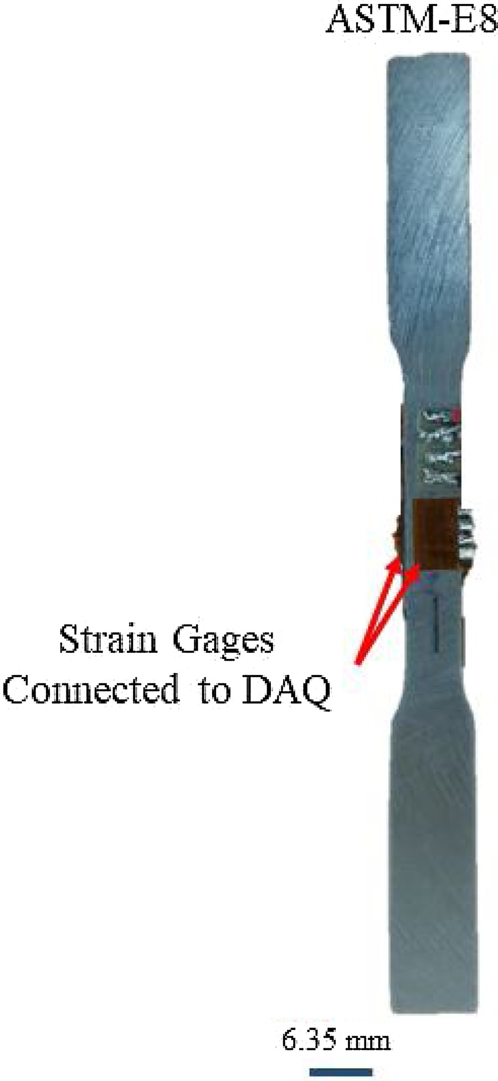
either side of the gage length of the specimen (Fig. 3). The surface of the specimens was machined to nominal conditions to facilitate proper attachment of the strain gages. All testing runs were performed at room temperature. Strain was measured by applying a quasi-static load in ten equal increments starting from 400 N and increasing up to 4 kN . This procedure was repeated three times on each specimen to determine average Poisson’s ratio and elastic modulus along the orthogonal planes.
2.3.2. Micro-hardness test
Micro-hardness test samples were fabricated as cylindrical test coupons with a diameter of 9.525 mm (3/8") and height of 50.8 mm (2") Segments from the cylindrical samples were cut from the center of the sample and embedded in epoxy resin solution. Mounted samples were prepared for micro-indentation through grinding and mechanical pol- ishing steps using MetPrep 3™ (Allied High Tech Products, Inc., USA) polishing discs. Silicon carbide discs of grit sizes 200, 320, 600, 800,
and 1200 were used for 5−8 min each. This process was followed by using felt polishing pads with 3- and 1-micron diamond slurries for 5 min each.
Microindentation was carried out to evaluate the micro-hardness across orthogonal processing planes with Vickers indentation using Qness micro-indentation hardness tester (Q60 A+, Qness, Austria) in accordance to ASTM E-384 [55]. The tip was loaded at 0.5 Kg and held
for 10 s before unloading at each indentation for a total of 100 in- dentations across a constant grid size of 0.5 0.5 mm in each AM build plane. A pyramid-shaped diamond Vickers indenter with an included angle of 136 was used. The Vickers hardness number - HV (kgf /mm2), was calculated using the Eq. 2 [56], where L is the indenter load (kgf ), A_{C} is the actual surface area (mm2) and d ( ) is the mean diagonal length of the residual diamond-shape impression in the specimen sur-
face.
HV = L = 2*L sin 136o = 1. 8544 L
A_{C}
d2
2
d2 (2)
Additionally, the yield strength ( _{Y} ) of the specimens was estimated using the Eq. 3 based on previous published reports [57–60].

HV 3 *
Y (3)

Fig. 3. Representative tensile testing specimens with implemented strain gage configuration. The second strain gage was attached on the opposing face.

  - Material properties
Two different techniques were used to obtain the orthotropic ma- terial properties of the L-PBF fixation plates: quasi-static tensile testing
Microindentation was treated as a post-hoc test for additional eva- luation of tensile testing results and was not included in the FEA stu- dies.
  - Finite element analysis (FEA)
    - Finite element modeling (FEM)
The FE models were developed using the parametric CAD model of the synthetic sawbone and fracture plate in Abaqus/CAE v6.13 (Simulia, Dassault Systems, Providence, USA) (Fig. 4D–F). The CAD models of the bone fragments and the implants were assembled in Geomagic Design X to accurately simulate implantation prior to im- porting into Abaqus for FE modeling. Screws were modeled as cylinders

and micro-indentation. All the material characterization test coupons
with a diameter of .0 mm that were merged with the plate to simulate

were fabricated and heat treated along with L-PBF implants.

2.3.1. Tensile test
Tensile testing was performed to obtain the orthotropic elastic moduli and Poison’s ratios associated with different AM processing planes. Tensile testing samples were prepared based on the ASTM E8/ E8M standard [52] using wire-EDM. Orthotropic material properties of the AM plates, namely Poisson’s ratio and elastic modulus were de- termined as per ASTM E132 [53] and ASTM E111 [54] standards. Three samples from each orthogonal orientation were machined to a nominal
width of 6.35 mm and a nominal thickness of 2.54 mm. Two micro-
measurement strain gages (CAE-06-062UT-350) were attached on
the threaded connection between screw head and plate [61,62]. Similar to the test constructs in experiments (Fig. 4A–C), screw lengths in the proximal head fragment were modeled as 40, 45, 40, 50, and 40 from A to E level, respectively (Fig. 2C). Medial strut (MS) groups (solid-MSS_{Y} and porous-MSP_{Y}) did not include the calcar (E-level) screws (Fig. 4D–F). All the distal screws in the humerus shaft were 40
in length. The 3-part fracture model had a 10 mm medial gap si- milar to the experimental setup (Section 2.5).
Boundary conditions and loading in the FEMs mimicked the three different biomechanical testing setups. A fully constrained rigid body plate was modeled to replicate the mechanical testing (Fig. 4 D–F). A compressive quasi-static load of 200 N was applied to a reference point which was constrained in 5 degrees-of-freedom (DoF) and free to

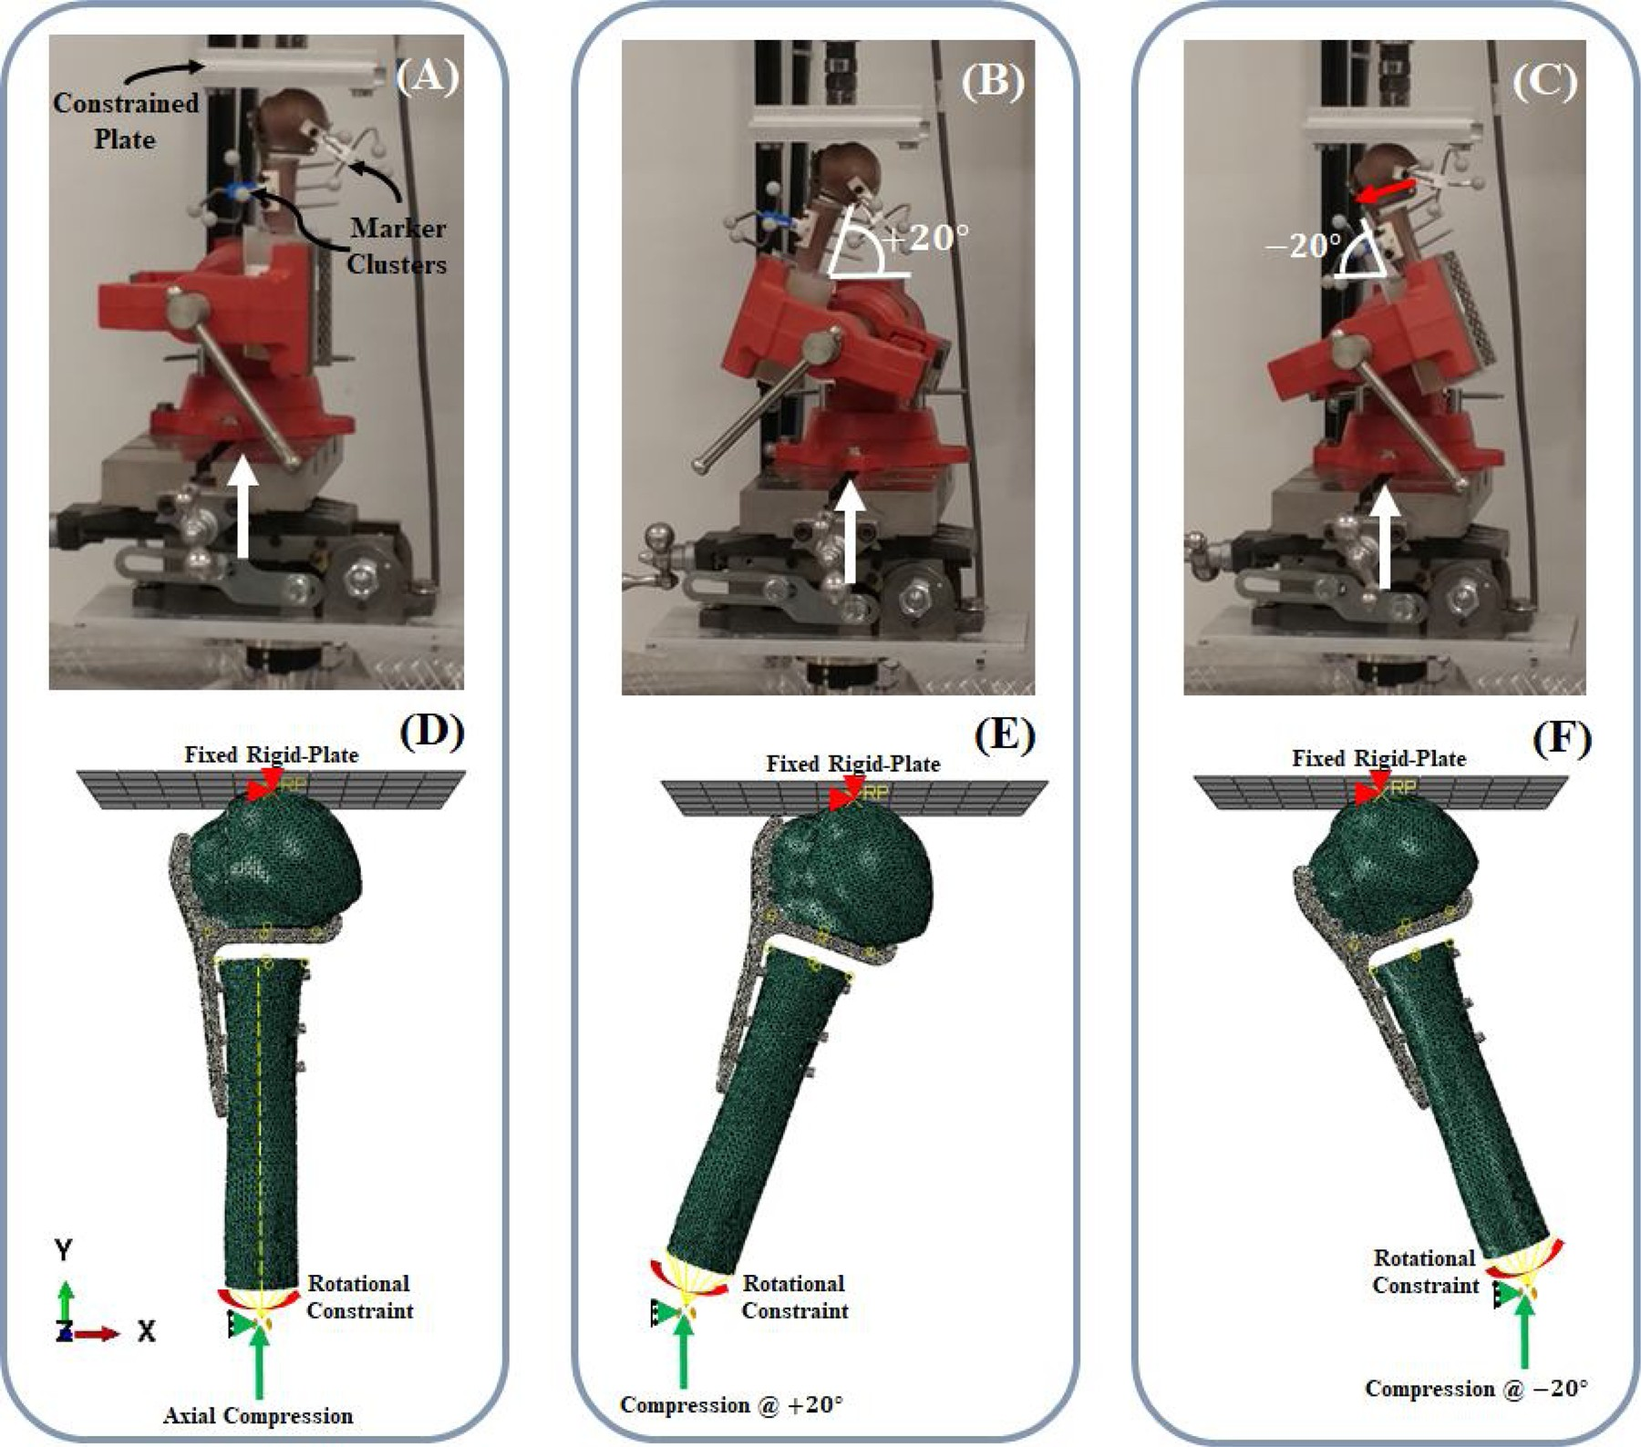
Fig. 4. Demonstration of quasi-static loading conditions in biomechanical testing (A-C) and corresponding FE models (D-F) (posterior view). (A, D) Axial 0 , (B, E)
20 abduction, and (C, F) 20 adduction.

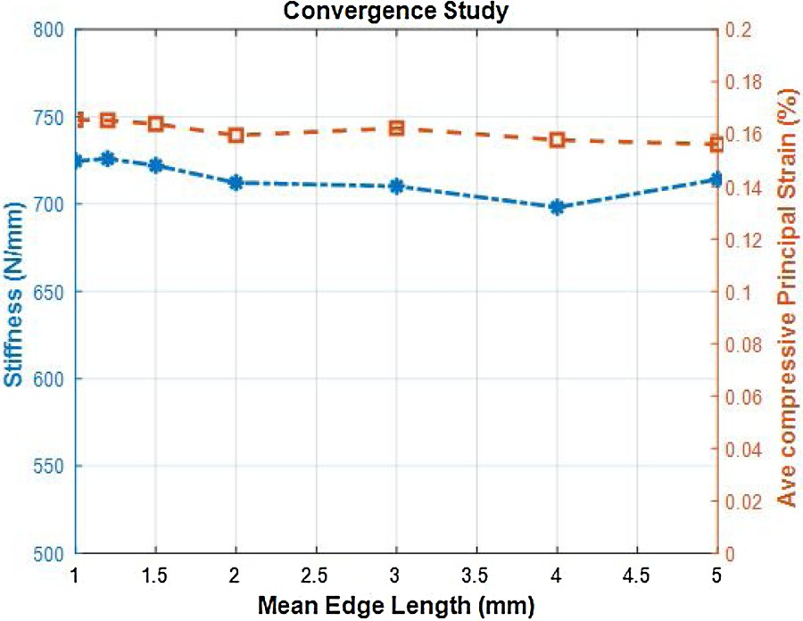
Fig. 5. Mesh convergence study based on mean compressive principal strains across the ROIs and predicted construct stiffness.

translate along the y-axis. Interactions at bone-bone and bone-implant interfaces were modeled as isotropic coulomb friction with coefficients of friction 0.4 and 0.1, respectively [63,64]. Screws were tied to the bone [61,62,65]. A mesh convergence study was conducted by varying
the mean element edge length from 1 to 5. Correspondingly, 1.5 mean edge length (1% convergence for mean compressive principal strains and stiffness) was used in this study to generate approximately
3.6 105 quadratic tetrahedron (C3D10) elements for the test con-
structs (Fig. 5). The rigid body plate in the FEMs was meshed using 50 linear quadrilateral elements. Material properties of cortical bone, trabecular bone, and conventional implant were modeled as linear elastic isotropic materials with Young’s Moduli of 17 GPa, 0.058 GPa, and 193 GPa, respectively. The Poison’s ratio was 0.3 for all these materials. Material properties of the synthetic bone were provided by Sawbones [66].
The L-PBF implants were modeled as orthotropic materials with three planes of symmetry and nine independent elastic constants in- cluding: (1) three elastic moduli (E ) in each of the three principal material directions, (2) three poison’s ratios ( ) describing the relation between axial and transverse strains, and (3) three shear moduli (G) to link the three modes of shear stress with strains. Correspondingly, the material properties of the L-PBF plates were defined by the constitutive equation described in Eq. 4. Orthotropic elastic moduli and Poison’s ratios were determined from tensile testing (Section 2.3.1). Since or- thotropic shear moduli of the L-PBF plate were not directly measured, Eqn. 5 was employed.

x /Ex
1/E_{x}
xy xz
=
y /E_{x}
z
yx /E y
1/E_{y}
yz/E y
zx /Ez 0 0 0
zy/Ez 0 0 0 xx
1/E_{z} 0 0 0 yy
zz
order to simulate the comminuted (gap) portion of the fracture, prior to the greater tuberosity fracture simulated with a planar saw cut. An orthopaedic surgeon (AA) performed implantation. Prior to implanta- tion, required length of screws at every level was planned using 3D CAD

xy
xz Symmetry
xy
1/G_{xy} 0 0 xz
model of the synthetic bone such that the tip of the proximal screws was
mm offset from the articular surface. In order to align the fracture

yz

E_{i} E_{j}
G =
ij
using ANSI 6-32 screws which have similar major (3.5
mm) and minor
1/G_{xz} 0 yz
1/G_{yz}
(4)
fragments with fixation plates accurately, implantation for 3-part comminuted fracture fixation plates to synthetic bones employed an- other custom PLA guide, providing higher repeatability and ease of assembly (contour of bone geometries do not facilitate 3-2-1 fixture
systems such as parallel vice). Conventional plates were fixed to bones

2(1 +
ij ji )
(5)
using 3.5
mm 316L SS locking surgical screws. L-PBF plates were fixed

2.4.2. Post-processing FEA results
(3.0
mm) diameters as the 316L SS surgical screws.
Prepared constructs were tested under nondestructive quasi-static

All the developed FEMs were analyzed using standard implicit static solver in Abaqus. A Python script was developed to automatically ex- tract output data from the generated. odb files for further post pro- cessing in MATLAB (Mathworks, Natick, MA). In this study, predicted stiffness results were used for validation of the simulation [67,68].
Minimum principal strains around the screws were evaluated to estimate failure of the construct. Recent cadaver studies have shown that minimum principal strains around the screws are directly corre- lated to screw cut-out under cyclic loading [67,68]. Based on these published methods, nodal-coordinates of the screws were used to fit
cylindrical regions-of-interest (ROIs) with a diameter of 8 mm in MA-
TLAB in the trabecular bone volume around each screw (Fig. 6). Vo- lume-weighted average of the minimum principal strains in the ROIs were determined and used as the predicting factor for screw cut-out [62].

  - Quasi-static biomechanical testing
A total of 15 synthetic humerus bones (Large Left 4th Generation Composite Humerus, 10# solid foam cancellous core, Sawbones, Vashone, WA), three bones per experimental group (n = 3) were pre- pared for biomechanical testing. A consistent 3-part comminuted frac- ture was simulated in all the specimens with the aid of a custom PLA (Polylactic Acid) guide that was fabricated using material extrusion
conditions in accordance to previous studies [42,69–71]. All the me- chanical tests were performed in a universal test frame (Electroforce 3550, TA Instruments, Eden Prairie, MN). Three different axial com- pression loading modes with the humeral shaft axis oriented at angles of 0 , 20 , 20 with respect to loading direction (Fig. 4A–C) were investigated [72]. Axial compression loading modes were performed by applying load at rate of 0.1 mm/s until reaching 200 N to the distal end
of the constructs. The 20 abduction (Fig. 4B) was included to si-
mulate shear loading across proximal fracture site as experienced during rising out of a chair or crutch weight bearing [70,71]. The 20 adduction (Fig. 4C) was based on the previous in-vivo study which si- mulates typical glenohumeral contact force directions [73]. Relative proximal head displacement with respect to the distal shaft was mea- sured using a 3-D motion capture system (Optitrack, NaturalPoint, Inc., Corvallis, OR) by recording the motion of the marker clusters attached to the humeral head and the distal shaft fragments. The 3-D motion capture system was calibrated within an accuracy of 0.2 mm to record the relative displacement between the bone fragments at a sampling rate of 30 Hz .

Result
  - Material characterization
Orthotropic elastic moduli and the Poisson’s ratios of the L-PBF

(MakertBot 2, MakerBot Industries, LLC, New York, NY). A 0 mm wide
implants that were obtained from tensile testing (Table 4) were em-

zone of the surgical neck was removed distal to the humeral head in
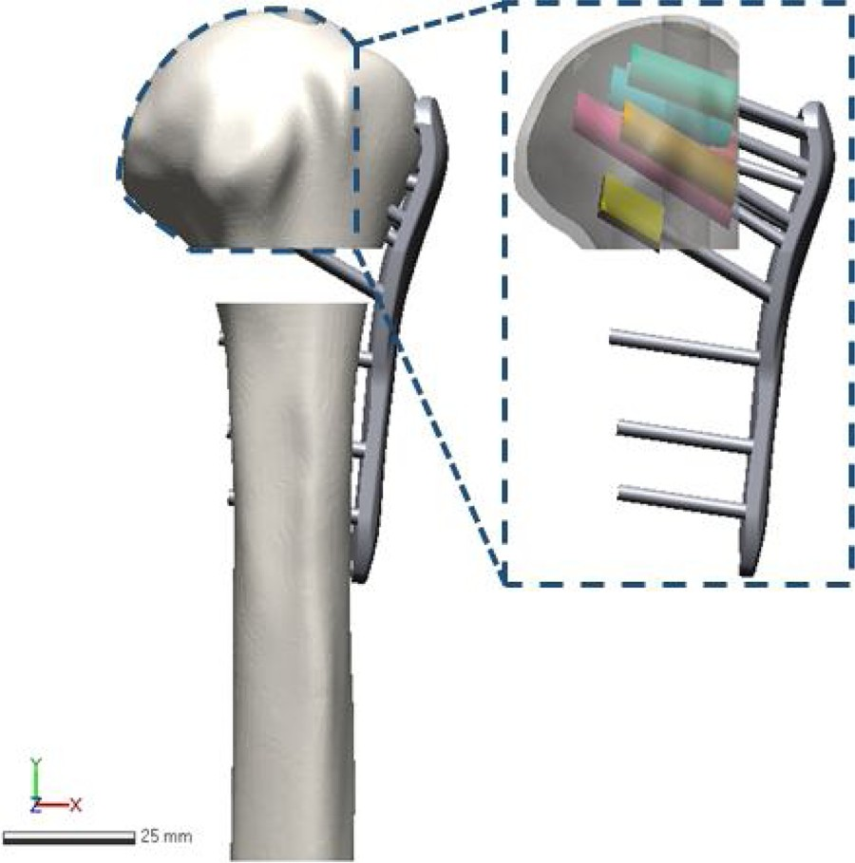
Fig. 6. Schematic diagram of the ROIs for evaluation of compressive principal strains.
ployed in the FE modeling of the proximal humerus fractures constructs with AM plates. As detailed in Section 2.4.1, the orthotropic shear moduli were calculated using Eq. 5. The differences between ortho- tropic elastic moduli averaged only 1.7 %, but the Poisson’s ratios de- viated by 38 % between _{XY} and _{XZ}. Post-hoc microindentation testing was employed to evaluate the differences in hardness between ortho- gonal processing planes (Fig. 7). The micro-hardness across the YZ processing plane was 7.8 % more than XY plane (Table 5). On average, micro-hardness of L-PBF parts in this study were observed to be at least 49 % higher than forged SS316L parts. In addition, considerably higher yield strength (> 60 %) based on Eq. 3 was observed in L-PBF samples which is consistent with previously reported studies on L-PBF SS316L [74–76].
  - Computationally predicted fixation stability
FE models predicted higher construct stiffness compared to bio- mechanical testing. Maximum deviation of construct stiffness between the predicted and experimental results was 30 %. This deviation can be attributed to ideal boundary conditions and shear locking phenomena in computational models as reported previously [65,79,80]. In order to evaluate the risk of screw cut-out failure across design groups, mean compressive principal strains in ROIs (Section 2.5.2) were analyzed on both: (1) volume-weighted average across screws and (2) individual screws (Fig. 8). The RE_{Y}, RE_{Z} and Conventional groups showed similar

SS 316L Material properties from tensile testing of _{L}-PBF implant samples.
 | E_{X} (GPa) | E_{Y} (GPa) | E_{Z} (GPa) | XY | XZ | YZ | G_{XY} (GPa) | G_{XZ} (GPa) | G_{YZ} (GPa)
Mean | 214.66 | 210.93 | 207.27 | 0.234 | 0.323 | 0.317 | 86.23 | 80.07 | 79.55

Std 1.66 7.94 1.63 0.017 0.006 0.006 1.65 1.53 0.62

mean compressive principal strains in the individual and averaged across the ROIs. On the other hand, MSS_{Y} reduced the average com- pressive principal strain experienced in the humeral head trabecular bone by 12.6 %, 23.17 %, and 7.9 % at axial, abduction, and adduction, respectively (Fig. 8). In general, MSP_{Y} plate showed similar bio- mechanical behavior as the MSS_{Y} plate.
  - Biomechanical testing
Quasi-static biomechanical testing showed that RE_{Y} plates behave similar to conventional locking plates in providing resistance to fracture gap displacement (Fig. 9). Solid medial strut (MSS_{Y}) design constructs experienced smaller fracture gap displacement when compared to re- verse-engineering conventional design (RE_{Y}). Porous medial strut (MSP_{Y}) experienced smaller fracture gap displacement when compared to reverse-engineering conventional design (RE_{Y}) and solid strut (MSS_{Y}) in the case of the most physiological relevant abduction loading con- dition. There was a considerable effect of build orientation on the biomechanical performance of the fracture fixation plate. RE_{Z} plate presented 59.7 % more resistance to fracture gap displacement on average in comparison to RE_{Y} plates but the mean displacement of RE_{Z} was within the range of RE_{Y}’s displacement results.

Discussion
  - Material characterization
Orthotropic material properties of the L-PBF SS316L from tensile testing were used in FE modeling of the AM implants. Tensile testing results showed smaller variation of elastic and shear moduli among the orthogonal build orientations 1.7 % and 7.7 %, respectively. However, Poisson’s ratio varied substantially (38 %) between XY and XZ or YZ planes. In comparison to a previous similar study that investigated anisotropic material properties of SS316L parts without any heat treatment [76], it can be concluded that residual stress removal and improved fusion between scan tracks and layers reduces the differences in microstructure and inherent anisotropy in mechanical properties. In

addition, the surface of the tensile testing specimens was machined in this study, which would eliminate the effect of as-built surface rough- ness.
The microhardness was evaluated across orthogonal processing planes. These results were in agreement with previous reports [74–76] and exhibited substantially higher (49 %) hardness value compared to forged SS316L. This difference could be attributed to the fast cooling process of L-PBF which results in refined microstructure and higher microhardness [81]. Orthogonal processing planes (YZ) exhibited 7.8 % higher microhardness, which highlights the effect of build direction. Orthotropic yield strength was estimated from the measured micro- hardness based on established “three-times” rule (Eq. 3) which states that the Vickers hardness of a material is approximately three times its yield strength [57–60]. However, the estimated strength might be slightly different from the measured yield strength [74–76]. This de- viation could be attributed to: (1) weak linear relation between mi- crohardness and strength in AM metal alloys which may not adhere to
three-times relationship, and the elastic constraint value might be
smaller than three [59], and (2) L-PBF process parameters and heat treatment procedure in this study are slightly different from other si- milar reports.
  - Reduced risk of screw cut-out
Mean compressive principal strains around the proximal screws in the trabecular region of the head fragment were used as the predicting parameter for screw cut-out failure, based on recent reports [67,68]. Proposed medial strut concepts, both solid and porous, showed reduced average compressive principal strains across the ROIs for all three in- vestigated loading modes. In addition, individual evaluation of the ROIs indicated that the new design reduces mean compressive principal strains around the A–D levels screws when compared to conventional design. AM reversed engineered implants (without the medial strut) presented similar risk of screw cut-out as the conventional locking fixation plates. In addition, it was observed that both solid and porous medial strut concepts offer similar biomechanical behavior. The porous medial strut may facilitate bone ingrowth and osseointegration of the

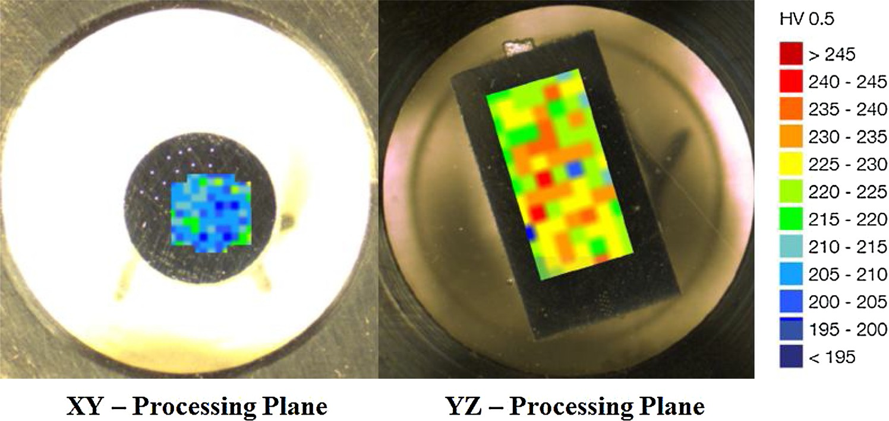
Fig. 7. Representative illustration of micro-hardness measurement grid across orthogonal processing planes.

Table 5
Summary of the Micro-hardness results for AM processing planes compared with previous L-PBF and forged SS316L results.
Mean Std (HV) 95 % Confidence Interval (CI) (HV) Est. Yield Strength (MPa)
L-PBF: XY Plane 209.68 5.85 [208.58, 210.77] 685.44
L-PBF:YZ Plane 226.00 7.37 [224.46, 227.54] 738.79
L-PBF [74–76] 220-279 – 719-912
Forged [77,78] 133-140 – 434-458

implant, collectively, these findings suggest that the proposed AM- centric implant design, specifically the medial strut concept, can reduce the risk of screw cut-out failure, at least in fixation of clinically difficult and unstable proximal humerus fractures with a comminuted neck zone.
  - Reduced varus collapse
Results from quasi-static biomechanical testing also showed that the proposed medial support provides more resistance to medial fracture gap displacement when compared to conventional and RE_{Y} plates across all three investigated loading modes. This indicates that risk of varus collapse, which is known to be one of the main postoperative

complications in proximal humerus fracture fixations [82–84], could be reduced with new medial support concepts that can be easily im- plemented via AM. Another important finding of this study was the similarity in biomechanical behavior of AM reversed-engineered im- plants (RE_{Y}) and conventional plates. With RE group, mean fracture gap displacement between RE_{Y} and RE_{Z} groups were different. This devia- tion in average displacement might be attributed to the effect of build orientation on the strength and resistance of the plate to deformation. This deviation in mechanical performance was not evident in tensile testing and microhardness results likely due to removal of as-built surface roughness through machining. As-built surface roughness is shown to be dependent on build direction, scanning strategy, powder size distribution, post heat-treatment as well as position [76,85–89].

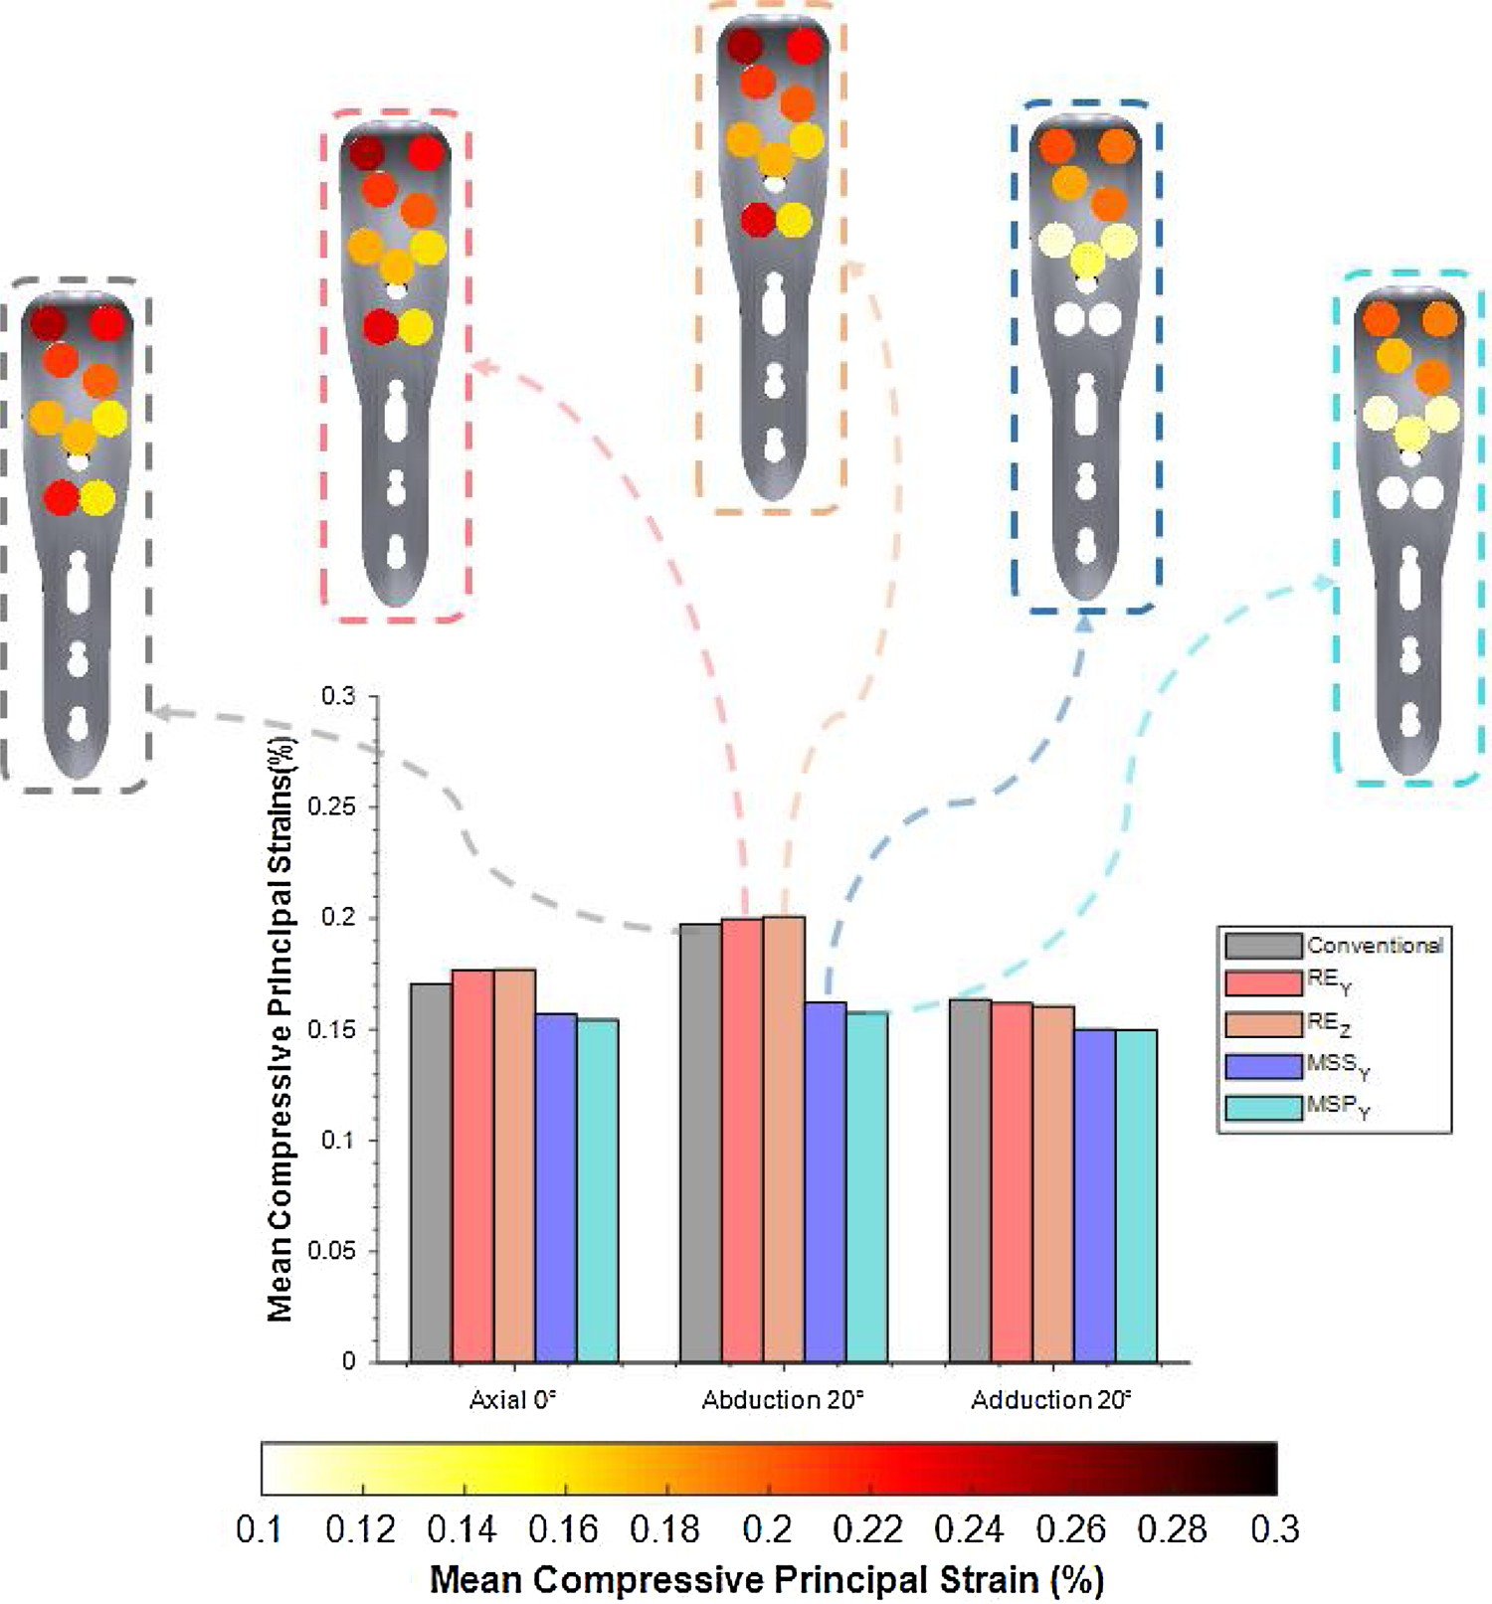
Fig. 8. FEA-predicted bone strains surrounding screws, a surrogate for risk of screw cut-out, across design groups. The bars indicate average compressive principal strains across all ROIs for all three different loading modes. The plate schematics represent mean compressive principal strains for individual ROIs surrounding each screw for the abduction loading condition.

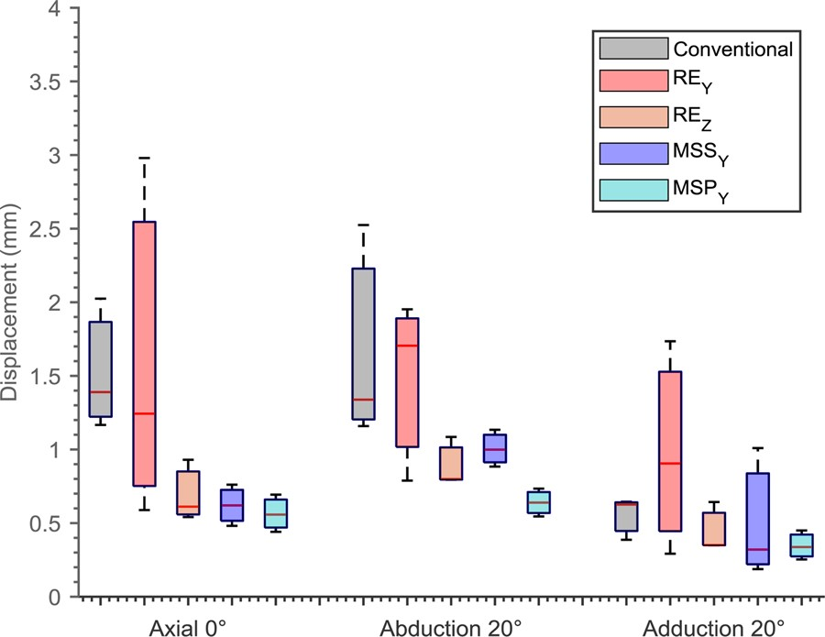
Fig. 9. Maximum fracture gap displacement determined from 3D motion tracking during biomechanical testing.

Therefore, mechanical performance of the L-PBF parts which is also dependent on surface roughness [76,90] can be modified during L-PBF processing. In order to better understand this aspect of AM made im- plants, biomechanical testing with larger sample size of both synthetic and cadaveric bones is required. In addition, future efforts will include experimental evaluation of the micromotion at the bone-implant in- terface via digital image correlation (DIC) during increasing cyclic loading (e.g. 10–50 cycles). This effort can provide critical insight into the local surface deformation (i.e. strains) at the interface of both bone fragments and bone-implant interface.
In summary, this study presented a comprehensive evaluation of the AM design and fabrication, material characterization, orthotropic FE analysis, and biomechanical evaluation of fracture fixation implants. Unique benefits of unparalleled design freedom offered by AM were harnessed to improve the biomechanical stability of the fracture fixa- tion implants for complex shoulder fractures. Comprehensive evalua- tion of the implemented workflow provides preliminary evidence of potential advantages of AM in orthopaedics. In order to accelerate the adoption of AM for orthopaedic applications, additional efforts related to medical device regulation (MDR) is required. It could include: (1) establishing a standard workflow for optimum cleaning and steriliza- tion of AM implants which could be challenging in cases of porous structures, (2) developing standard process parameters for each bio- compatible material and AM technique to achieve more consistent bio- mechanical properties, and (3) studying the multi-factorial cost com-
ponents of AM medical device development and regulation. The im-
portant factor of cost remains a major barrier to broader adoption of AM in personalized medicine. However, considering the ever-growing adoption of AM in dental industry [91], it is believed that similar growth could be achieved for AM use in orthopaedic implants.

Conclusion
In this study, a systematic workflow was designed and developed to evaluate AM fabrication of fracture fixation implants. A patient-specific AM–centric design concept was proposed and investigated with the aim of reducing common post-operative complications in proximal humerus fracture fixation – screw cut-out and varus collapse. Following con- clusions are drawn from the outcomes of this study:
•
New metal implant designs can be rapidly produced along with post- processing, surgical planning and surgical guides in less than 24 h for complex fracture surgeries (∼23 h in this study).
•
Metal AM offers the ability to fabricate patient-specific fracture fixation plates for proximal humerus fractures based on fracture type, patient’s anatomy and bone quality, which can significantly
improve the quality of the reduction.
This study reports the first investigation on the use of metal AM for complex 3-part fractures.
•
•
Proposed design concept of medial support is relatively easier to design, fabricate and evaluate through the implemented AM work- flow
•
Results show that proposed design concept can be successful in re- ducing the risk of varus collapse and screw cut-out. Larger sample size and cadaver studies is warranted in future work. Clinical aspects including avoiding disruption of soft tissues surrounding the medial aspect of the humerus should also be considered.
•
Validation of AM for orthopaedic applications requires concurrent evaluation of material and biomechanical properties of implants, especially when new design concepts are proposed.
•
FE modeling of the AM materials continues to be challenging. More effective and computationally feasible material models is required to incorporate orthotropic material properties of AM parts, effects of surface roughness, and AM process parameters.
•
This study provides preliminary evidence of the potential translation of benefits of patient-specific AM fracture fixation plates in ortho- paedic surgery. However, the impact of AM workflow on cost of implant development and regulation needs to be well understood.

CRediT authorship contribution statement
Maryam Tilton: Conceptualization, Methodology, Formal analysis, Investigation, Software, Data curation, Writing - original draft, Visualization. Gregory S. Lewis: Conceptualization, Methodology. Hwa Bok Wee: Software. April Armstrong: Conceptualization, Methodology. Michael W. Hast: Resources. Guha Manogharan: Conceptualization, Methodology, Resources, Writing - review & editing, Supervision.

Acknowledgment
Authors would like to acknowledge Ryan Overdorff, Applied Research Scientist from 3D Systems, Inc., for his assistant and guidance with AM processing.

Appendix A. Supplementary data
Supplementary material related to this article can be found, in the online version, at doi:https://doi.org/10.1016/j.addma.2020.101137.

References

- S.A. Khanoki, Multiscale Mechanics and Multiobjective Optimization of Cellular Hip Implants with Variable Stiffness, No. April, (2013).
- S. Arabnejad, B. Johnston, M. Tanzer, D. Pasini, Fully porous 3D printed titanium femoral stem to reduce stress-shielding following total hip arthroplasty, J. Orthop. Res. 35 (8) (2017) 1774–1783.
- X. Wang, et al., Topological design and additive manufacturing of porous metals for bone scaffolds and orthopaedic implants: a review, Biomaterials 83 (March) (2016) 127–141.
- A.S.M. Croitoru, B.A. Pacioga, C.S. Comsa, Personalized hip implants manu- facturing and testing, Appl. Surf. Sci. 417 (2017) 256–261.
- L.M.A. Sharma, S.J.A.S.A. Tiwari, Three ‑ Dimensional Printing and Patient ‑ Specific Pre ‑ Contoured Plate : Future of Acetabulum Fracture Fixation? (2018), pp. 215–224.
- A.L. Jardini, et al., Cranial reconstruction: 3D biomodel and custom-built implant created using additive manufacturing, J. Craniomaxillofac. Surg. 42 (Dec (8)) (2014) 1877–1884.
- M. Cronskär, L.-E. Rännar, M. Bäckström, K.G. Nilsson, B. Samuelsson, Patient- specific clavicle reconstruction using digital design and additive manufacturing, J. Mech. Des. 137 (Nov (11)) (2015).
- C. Neer, Displaced proximal humeral fractures, Orthop. Trauma Dir. 5 (Jul (4)) (2007) 25–29.
- R. Hertel, Fractures of the proximal humerus in osteoporotic bone, Osteoporos. Int. 16 (Mar (S02)) (2005) S65–S72.
- A. Jabran, C. Peach, L. Ren, Biomechanical analysis of plate systems for proximal humerus fractures: a systematic literature review, Biomed. Eng. Online (2018)

1–30.
- M. Xu, et al., Custom-made locked plating for acetabular fracture: a pilot study in 24 consecutive cases, Orthopedics (2014) 660–671.
- P. Upex, P. Jouffroy, G. Riouallon, Application of 3D printing for treating fractures of both columns of the acetabulum: benefit of pre-contouring plates on the mirrored healthy pelvis, Orthop. Traumatol. Surg. Res. 103 (3) (2017) 331–334.
- B.J. Merema, et al., The design, production and clinical application of 3D patient- speci fi c implants with drilling guides for acetabular surgery, Injury 48 (11) (2017) 2540–2547.
- L. Maini, T. Verma, A. Sharma, A. Sharma, A. Mishra, S. Jha, Evaluation of accuracy of virtual surgical planning for patient-specific pre-contoured plate in acetabular fracture fixation, Arch. Orthop. Trauma Surg. 138 (4) (2018) 495–504.
- S.L. Sing, J. An, W.Y. Yeong, F.E. Wiria, Laser and electron-beam powder-bed ad- ditive manufacturing of metallic implants: a review on processes, materials and designs, J. Orthop. Res. 34 (Mar (3)) (2016) 369–385.
- M. Tilton, G.S. Lewis, G.P. Manogharan, Additive manufacturing of orthopedic implants, in: B. Li, T. Webster (Eds.), Orthopedic Biomaterials : Progress in Biology, Manufacturing, and Industry Perspectives, Springer International Publishing, Cham, 2018, pp. 21–55.
- H.E. Burton, S. Peel, D. Eggbeer, Reporting fidelity in the literature for computer aided design and additive manufacture of implants and guides, Addit. Manuf. 23 (June) (2018) 362–373.
- M.J. Gardner, Y. Weil, J.U. Barker, B.T. Kelly, D.L. Helfet, D.G. Lorich, The im- portance of medial support in locked plating of proximal humerus fractures, J. Orthop. Trauma 21 (2007) 185–191.
- M.J. Jo, M.J. Gardner, Proximal humerus fractures, Curr. Rev. Musculoskelet. Med. 5 (3) (2012) 192–198.
- H. Lill, et al., Proximal humeral fractures: how stiff should an implant be? A comparative mechanical study with new implants in human specimens, Arch. Orthop. Trauma Surg. 123 (2–3) (2003) 74–81.
- F. Fankhauser, C. Boldin, G. Schippinger, C. Haunschmid, R. Szyszkowitz, A new locking plate for unstable fractures of the proximal humerus, Clin. Orthop. Relat. Res. (430) (2005) 176–181.
- K.A. Egol, C.C. Ong, M. Walsh, L.M. Jazrawi, N.C. Tejwani, J.D. Zuckerman, Early complications in proximal humerus fractures (OTA Types 11) treated with locked plates, J. Orthop. Trauma 22 (3) (2008) 159–164.
- P. Clavert, P. Adam, A. Bevort, Pitfalls and complications with locking plate for proximal humerus fracture, J. shoulder Elb. Surg. 19 (4) (2010) 489–494.
- R.C. Sproul, J.J. Iyengar, Z. Devcic, B.T. Feeley, A systematic review of locking plate fixation of proximal humerus fractures, Injury 42 (4) (2011) 408–413.
- L.E. Murr, S.M. Gaytan, E. Martinez, F. Medina, R.B. Wicker, Next generation or- thopaedic implants by additive manufacturing using electron beam melting, Int. J. Biomater. 2012 (2012).
- M. Cronskär, M. Bäckström, L. Rännar, L.-E. Rännar, Rapid Prototyping Journal Production of customized hip stem prostheses – a comparison between conventional machining and electron beam melting (EBM), Rapid Prototyp. J. 19 (4) (2012) 365–372.
- H.M.A. Kolken, Rationally Designed Meta-implants: A Combination of Auxetic and Conventional Meta-biomaterials vol. 5, (2018) no. 1.
- S. Mazzoni, A. Bianchi, G. Schiariti, G. Badiali, C. Marchetti, Computer-aided design and computer-aided manufacturing cutting guides and customized titanium plates are useful in upper maxilla waferless repositioning, J. Oral Maxillofac. Surg. 73 (April (4)) (2015) 701–707.
- S.M. Toso, K. Menzel, Y. Motzkus, N. Adolphs, B. Hoffmeister, J.-D. Raguse, Patient- specific implant in prosthetic craniofacial reconstruction, J. Craniofac. Surg. 26 (October (7)) (2015) 2133–2135.
- A.R. Hsu, J.K. Ellington, Patient-specific 3-dimensional printed titanium truss cage with tibiotalocalcaneal arthrodesis for salvage of persistent distal tibia nonunion, Foot Ankle Spec. 8 (Dec (6)) (2015) 483–489.
- H. Fan, et al., Implantation of customized 3-D printed titanium prosthesis in limb salvage surgery: a case series and review of the literature, World J. Surg. Oncol. 13 (1) (2015) 1–10.
- K.C. Wong, S.M. Kumta, N.V. Geel, J. Demol, One-step reconstruction with a 3D- printed, biomechanically evaluated custom implant after complex pelvic tumor resection, Comput. Aided Surg. 20 (1) (2015) 14–23.
- H. Liang, T. Ji, Y. Zhang, Y. Wang, W. Guo, Reconstruction with 3D-printed pelvic endoprostheses after resection of a pelvic tumour, Bone Joint J. 99-B (Feb (2)) (2017) 267–275.
- J.L. Aranda, M.F. Jiménez, M. Rodríguez, G. Varela, Tridimensional titanium- printed custom-made prosthesis for sternocostal reconstruction, Eur. J. Cardio- Thoracic Surg. 48 (Oct (4)) (2015) e92–e94.
- N. Xu, et al., Reconstruction of the upper cervical spine using a personalized 3D- printed vertebral body in an adolescent with ewing sarcoma, Spine (Phila. Pa. 1976) 41 (1) (2016) 50–54.
- W.J. Choy, R.J. Mobbs, B. Wilcox, S. Phan, K. Phan, C.E. Sutterlin, Reconstruction of thoracic spine using a personalized 3D-printed vertebral body in adolescent with T9 primary bone tumor, World Neurosurg. 105 (September) (2017) 1032.e13–1032.e17.
- K. Phan, A. Sgro, M.M. Maharaj, P. D’Urso, R.J. Mobbs, Application of a 3D custom printed patient specific spinal implant for C1/2 arthrodesis, J. spine Surg. (Hong Kong) 2 (Dec (4)) (2016) 314–318.
- R.J. van Arkel, S. Ghouse, P.E. Milner, J.R.T. Jeffers, Additive manufactured push- fit implant fixation with screw-strength pull out, J. Orthop. Res. 36 (5) (2018) 1508–1518.
- M. Takemoto, et al., Additive-manufactured patient-specific titanium templates for thoracic pedicle screw placement: novel design with reduced contact area, Eur.

Spine J. 25 (2016) 1698–1705.
- F. O’Neill, F. Condon, T. McGloughlin, B. Lenehan, C. Coffey, M. Walsh, Validity of synthetic bone as a substitute for osteoporotic cadaveric femoral heads in me- chanical testing: a biomechanical study, Bone Joint Res. 1 (4) (2012) 50–55.
- S. Mehta, M. Chin, J. Sanville, S. Namdari, M.W. Hast, Calcar screw position in proximal humerus fracture fixation: don’t miss high!, Injury (2018) 2–7.
- L. Zhang, et al., The clinical benefit of medial support screws in locking plating of proximal humerus fractures : a prospective randomized study, Int. Orthop. 35 (11) (2011) 1655–1661.
- V. Karageorgiou, D. K. Ã, Porosity of 3D biomaterial scaffolds and osteogenesis, Biomaterials 26 (27) (2005) 5474–5491.
- N. Taniguchi, et al., Effect of pore size on bone ingrowth into porous titanium implants fabricated by additive manufacturing: An in vivo experiment, Mater. Sci. Eng. C 59 (1) (2016) 690–701.
- A.C. Jones, C.H. Arns, A.P. Sheppard, D.W. Hutmacher, B.K. Milthorpe,
M.A. Knackstedt, Assessment of bone ingrowth into porous biomaterials using MICRO-CT, Biomaterials 28 (15) (2007) 2491–2504.
- A.B. Spierings, N. Herres, G. Levy, Influence of the particle size distribution on surface quality and mechanical properties in AM steel parts, Rapid Prototyp. J. 17 (April 3) (2011) 195–202.
- N.P. Lavery, et al., Effects of hot isostatic pressing on the elastic modulus and tensile properties of 316L parts made by powder bed laser fusion, Mater. Sci. Eng. A 693 (March) (2017) 186–213.
[48] N.A. Stainless, “Aisi316,” 13 (1) (2007).
- B. Song, S. Dong, Q. Liu, H. Liao, C. Coddet, Vacuum heat treatment of iron parts produced by selective laser melting:21 Microstructure, residual stress and tensile behavior, Mater. Des. 54 (2) (2014) 727–733.
- R. Wauthle, et al., Effects of build orientation and heat treatment on the micro- structure and mechanical properties of selective laser melted Ti6Al4V lattice structures, Addit. Manuf. 5 (2015) 77–84.
- S. Steel, M. Products, C. Axial, F. Application, “Specification ASTM E8,”, (2019), pp. 1–30.
- T. Modulus, C. Modulus, C. Axial, F. Application, Standard Test Method for Poisson’s Ratio at Room Temperature 1, Vol. 04, No. Reapproved 2010, (2013), pp. 1–3.
- ASTM, E 0111 Young’s Modulus, Tangent Modulus and Chord Modulus, Astm, 04, no. Reapproved 2010, 2010, pp. 1–7.
- A.S.T.M. Standard, E384-17 Standard Test Method for Microindentation Hardness of Materials, ASTM Int. (2017) 1–40.
- E. Broitman, M.Á.N.Á.M.Á, Indentation hardness measurements at macro-, micro-, and nanoscale : a critical overview, Tribol. Lett. 65 (1) (2017) 1–18.
- M.F. Ashby, D.R.H. Jones, Engineering Materials 1: an Introduction to Properties, Applications and Design vol. 1, Elsevier, 2012.
- D. Tabor, The Hardness of Metals, Oxford university press, 2000.
- P. Zhang, S.X. Li, Z.F. Zhang, General relationship between strength and hardness, Mater. Sci. Eng. A 529 (1) (2011) 62–73.
- L. Lu, R. Schwaiger, Z.W. Shan, M. Dao, K. Lu, S. Suresh, Nano-sized twins induce high rate sensitivity of flow stress in pure copper, Acta Mater. 53 (April 7) (2005) 2169–2179.
- J.A. Inzana, P. Varga, M. Windolf, Implicit modeling of screw threads for efficient finite element analysis of complex bone-implant systems, J. Biomech. 49 (9) (2016) 1836–1844.
- P. Varga, L. Grünwald, J.A. Inzana, M. Windolf, Fatigue failure of plated osteo- porotic proximal humerus fractures is predicted by the strain around the proximal screws, J. Mech. Behav. Biomed. Mater. 75 (March) (2017) 68–74.
- F. Ezquerro, S. Jiménez, A. Pérez, M. Prado, G. de Diego, A. Simón, The influence of wire positioning upon the initial stability of scaphoid fractures fixed using Kirschner wires, Med. Eng. Phys. 29 (Jul.no. 6) (2007) 652–660.
- J. Nedoma, J. Stehlik, Mathematical and Computational Methods in Biomechanics of Human Skeletal Systems Vol. 12 John Wiley & Sons, 2011.
- P. Varga, J.A. Inzana, B. Gueorguiev, N.P. Südkamp, M. Windolf, Validated com- putational framework for efficient systematic evaluation of osteoporotic fracture fixation in the proximal humerus, Med. Eng. Phys. 57 (2018) 29–39.
- P. Varga, L. Grünwald, M. Windolf, The prediction of cyclic proximal humerus fracture fixation failure by various bone density measures, J. Orthop. Res. 36 (8) (2018) 1–9.
- P. Varga, L. Grünwald, M. Windolf, The prediction of cyclic proximal humerus fracture fixation failure by various bone density measures, J. Orthop. Res. (2018) 1–9.
- J.M. Goffin, P. Pankaj, A.H. Simpson, Are plasticity models required to predict re- lative risk of lag screw cut-out in finite element models of trochanteric fracture fixation? J. Biomech. 47 (2014) 323–328.
- J.C. Katthagen, M. Schwarze, M. Warnhoff, C. Voigt, C. Hurschler, H. Lill, Influence of plate material and screw design on stiffness and ultimate load of locked plating in osteoporotic proximal humeral fractures, Injury 47 (3) (2016) 617–624.
- J.C. Katthagen, M. Schwarze, J. Meyer-Kobbe, C. Voigt, C. Hurschler, H. Lill, Biomechanical effects of calcar screws and bone block augmentation on medial support in locked plating of proximal humeral fractures, Clin. Biomech. 29 (7) (2014) 735–741.
- J. Lescheid, R. Zdero, S. Shah, P.R.T. Kuzyk, E.H. Schemitsch, The biomechanics of locked plating for repairing proximal humerus fractures with or without medial cortical support, J. Trauma - Inj. Infect. Crit. Care 69 (5) (2010) 1235–1242.
- M. Tilton, et al., Biomechanical testing of additive manufactured proximal humerus fracture fixation plates, Ann. Biomed. Eng. 48 (1) (2020) 463–476.
- G. Bergmann, F. Graichen, A. Bender, M. Kääb, A. Rohlmann, P. Westerhoff, In vivo glenohumeral contact forces-Measurements in the first patient 7 months

postoperatively, J. Biomech. 40 (no. 10) (2007) 2139–2149.
- J. Kruth, P. Mercelis, J. Van Vaerenbergh, L. Froyen, M. Rombouts, Binding me- chanisms in selective laser sintering and selective laser melting, Rapid Prototyp. J. 11 (February 1) (2005) 26–36.
- Z.H. Liu, D.Q. Zhang, S.L. Sing, C.K. Chua, L.E. Loh, Interfacial characterization of SLM parts in multi-material processing: metallurgical diffusion between 316L stainless steel and C18400 copper alloy, Mater. Charact. 94 (August) (2014) 116–125.
- L. Hitzler, J. Hirsch, B. Heine, M. Merkel, W. Hall, A. Öchsner, On the anisotropic mechanical properties of selective laser-melted stainless steel, Materials (Basel) 10 (10) (2017).
- L. Zhang, J. Wang, Effect of temperature and loading mode on environmentally assisted crack growth of a forged 316L SS in oxygenated high-temperature water, Corros. Sci. 87 (2014) 278–287.
- T.F. Kong, L.C. Chan, T.C. Lee, Experimental study of effects of process parameters in forge-welding bimetallic materials: AISI 316L stainless steel and 6063 aluminium alloy, Strain 45 (Aug.no. 4) (2009) 373–379.
- J. Oh, et al., Effect of Fracture Gap on Stability of Compression Plate Fixation : A Finite Element Study, no. April, (2010), pp. 462–467.
- G. Dahan, N. Trabelsi, O. Safran, Z. Yosibash, Verified and validated finite element analyses of humeri, J. Biomech. 49 (7) (2016) 1094–1102.
- Z. Sun, X. Tan, S.B. Tor, W.Y. Yeong, Selective laser melting of stainless steel 316L with low porosity and high build rates, Mater. Des. 104 (2016) 197–204.
- E. Tan, D. Lie, M.K. Wong, Early outcomes of proximal humerus fracture fixation with locking plate and intramedullary fibular strut graft, Orthopedics 37 (9) (2014)

e822–e827.
- J.-H. Bae, J.-K. Oh, C.-S. Chon, C.-W. Oh, J.-H. Hwang, Y.-C. Yoon, The bio- mechanical performance of locking plate fixation with intramedullary fibular strut graft augmentation in the treatment of unstable fractures of the proximal humerus, Bone Joint J. 93-B (7) (2011) 937–941.
- C. Mathison, R. Chaudhary, L. Beaupre, M. Reynolds, S. Adeeb, M. Bouliane, Biomechanical analysis of proximal humeral fixation using locking plate fixation with an intramedullary fibular allograft, Clin. Biomech. 25 (7) (2010) 642–646.
- L. Hitzler, J. Hirsch, M. Merkel, W. Hall, Position Dependent Surface Quality in Selective Laser Melting, (2017), pp. 327–334.
- A.H. Maamoun, Y.F. Xue, M.A. Elbestawi, S.C. Veldhuis, “The Effect of Selective Laser Melting Process Parameters on the Microstructure and Mechanical Properties of Al6061 and AlSi10Mg Alloys,”, Materials (Basel). 12 (1) (2019).
- Y. Tian, D. Tomus, P. Rometsch, X. Wu, Influences of processing parameters on surface roughness of Hastelloy X produced by selective laser melting, Addit. Manuf. 13 (January) (2017) 103–112.
- M. Mohammadi, H. Asgari, Achieving low surface roughness AlSi10Mg_200C parts using direct metal laser sintering, Addit. Manuf. 20 (March) (2018) 23–32.
- Z. Chen, X. Wu, D. Tomus, C.H.J. Davies, Surface roughness of Selective Laser Melted Ti-6Al-4V alloy components, Addit. Manuf. 21 (May) (2018) 91–103.
- R. Shrestha, J. Simsiriwong, N. Shamsaei, Fatigue behavior of additive manu- factured 316L stainless steel parts: Effects of layer orientation and surface rough- ness, Addit. Manuf. 28 (Aug) (2019) 23–38.
- A. Dawood, B.M. Marti, V. Sauret-Jackson, A. Darwood, 3D printing in dentistry, Br. Dent. JournalDent J. 219 (11) (2015) 521–529 Dec.

